Into Math NL v2/CA
LXDV EMM SE & TE Guidelines

LXDV Intro to the EMM Guidelines 5
The Enhanced Math Manuscript 5
Module and Lesson Structure for Program 5
How to Approach the Content – LXDV Guidelines and Resources 5
Workflow Schedule and Issues Tracker 8
HMH Project Specific Acronym list 9
Important Links 9
Lesson Level Guidelines 13
Page 1 and Before You Teach 14
Page 1 14
Before You Teach 15
Learning Goal (Beginning and End) 22
Spark Your Learning and Review Spark Your Learning 26
Step 1: Introducing the Spark Your Learning Components 27
Step 3: Evaluating and Editing the V1 Components of a K-8 SYL 29
Step 4: Evaluating and Editing the V1 Components of an A1 SYL 32
Step 5: Authoring a New SYL from Scratch 34
Step 6: Placing Spark Your Learning Components and Authoring New Scripting in the EMM: 36
Step 7: Resources 42
Tasks 42
Reuse, Revise, or New? 43
Setting Up Tasks & Placing Content 46
Teaching Strategy for Tasks 60
Turn & Talk 61
Teaching Strategy for Turn & Talk 63
Depth of Knowledge Leveled Questions 64
Continuing with Tasks 2 and Beyond 64
Quick Check 65
Differentiation and Practice (TE Only) 70
Practice On Your Own 72
Module Level Guidelines 80
Module Opener Guidelines 81
Module Planning 81
Prerequisite Check 85
Module Closer Guidelines 93
Module Review 93
Kindergarten Considerations 102
Kindergarten Page Styling Guidelines 102
Multiple Versions of Images 106

UPDATES
August 28, 2024 | Updated the former Language Skills Domain excel sheet links to go to the ML Guidelines for the steps for the Language Objective.
July 30, 2024 | Updated the format for listing printables in the materials, and link to the Teacher Resource Masters.
July 23, 2024 | A “Grade Level Considerations - A1” box was added to the end of the Practice on Your Own section, outlining a goal of 75% of POYO v1 problems authored.
July 23, 2024 | Into Math Manipulative List has been updated for an A1 specific list
July 16, 2024 | Updated the Meaningful Descriptions and Keywords to be created and recorded in the MegaTrackers, and inserted the links to the 2 Mod/Lesson-Level MegaTrackers.
July 16, 2024 | Updated the Vocabulary Section #1 Bullet 3 to say If there are NO new or review vocabulary terms, include N/A in the rows of the table.
June 25, 2024 | Manipulatives List has been updated by removing items that were not used in V1 lessons. No new items were added.
June 25, 2024 | Added information regarding Teacher facing prompt for SYL Turn and Talks in G1-2 on pg. 25 (highlighted in yellow)
June 25, 2024 | Clarified to reference the Scope & Sequence Tab of the TOC spreadsheets for standard language under number 5 for “What should I understand about the math?” on pg. 11 (highlighted in yellow)
June 25, 2024 | Added reference to the Learnosity Question Type Use Cases Table Structure.docx as a resource for writing up items in all four Learnosity sections (AYR, QC, POYO, MDR).
June 25, 2024 | Changed “Common Error Tracker” to “Common Error Spreadsheet” and updated links so they point to the grade-specific Common Error spreadsheets. Highlighted in yellow. (rstewart)
June 27, 2024 | Added that materials should be listed in alphabetical order on pg. 15 (highlighted in yellow)
June 27, 2024 | What tools do I need? section updated to detail how to document manipulatives selected for a lesson in the MegaTracker.
July 2, 2024 | Edited mentions of Habitat from being (3-5) to being (3-A1) on pg. 18-19 (highlighted in yellow)
July 2, 2024 | Learning Goal Section: Info about how content will appear in print has been included on pg. 20 (highlighted in yellow)
July 2, 2024 | Spark Your Learning Section: Screengrabs updated on pg. 34 and 36 to indicate how print content will be added to left column in EMM.  Digital and print content will be set in predetermined ways. Info on pgs 33 and 34 for both SYL and SYL Turn and Talk (highlighted in yellow)
July 2, 2024 | Task Section: Info about how to present print information on the left-hand column in the EMM added on pgs. 42, (highlighted in yellow)
July 2, 2024 | Learnosity Section: Info about how to present print information on the left-hand column in the EMM added in all 4 Learnosity-based sections (highlighted in yellow)
July 2, 2024 | Module Level Guidelines> Module Planning Page: Included a link to the Vocabulary Guidelines in the vocabulary section (highlighted in yellow)
July 2, 2024 | Task Section: Included link to vocabulary guidelines in the vocabulary section (highlighted in yellow)
July 2, 2024 | Module Planning Page: Updated the link to the Vocabulary Tracker to allow for edit access. (highlighted in yellow)
July 2, 2024 | Important Links: Included links to the grade banded megatrackers (highlighted in yellow)
July 8, 2024 | Some standards have clarifying language (For example...) as part of the standard. Do not omit “For example...” when it is part of a standard. (Pg 72- highlighted in yellow)
July 9, 2024 | Additional information added about clarifying language (Pg 72- highlighted in yellow)
July 10, 2024 | Bold-faced “Words to Learn routine” on page 50 Consider section. Did not highlight in yellow to not confuse the boilerplate formatting.
July 11, 2024 | Clarifying standard language needed at module level only, not lesson level (pg 14 – highlighted in yellow)
July 12, 2024 | Updated bullets under Teaching Strategy for Turn & Talk (pg 56). Task 1 and beyond T&T support can be either ML or UDL.
July 16, 2024 | “Are You Ready” section in Module Opener EMM templates (and in the AYR section in this doc) have been changed to the same green color as “Quick Check” since it behaves the same way – as an assessment with no feedback or hints
July 17, 2024 | Standards Based Practice does not get included on the Differentiation & Practice page. (Pg. 67 – highlighted in yellow)
July 18, 2024 | Key Topics links have been updated.
July 22, 2024 | Math Item Specs Guide has been updated to include Tricky Parity Solutions section for Learnosity/Print items.
July 22, 2024 | Deleted the following text from the 4th bullet under item 3 on page 17, “, including “Differentiated Instruction” found on the Lesson Opener (C) page.  Any items that are used solely for Differentiated Instruction should be indicated with an asterisk in the EMM.”
July 22, 2024 | Deleted the following text from 4c on page 78, “Add an asterisk after materials that are used in small-group activities. If no lesson has materials that are used in small-group activities, delete the text after the last lesson table that reads “* Used in Small-Group Activity”.”
July 23, 2024 | Capitalized letters and removed colon from “Ask:” so that the format is correct: ASK (highlighted in yellow, pg 54)
July 24, 2024 | Added A1 Digital Manipulatives under Important Links.
July 25, 2024 | “Kindergarten Considerations” section added beginning on Pg 94
July 25, 2024 | Added Vocabulary section instructions for the Module Review under Module Closer Guidelines “Purpose of Component” bullet.  The Vocabulary Guidelines have also been updated with similar information.
July 25, 2024 | Added “iv. ELD Standards” for Steps for Completing EMM Module Opener Template under the Module Opener Guidelines.
July 26, 2024 | Updated Differentiation and Practice section under #3 with the following:  f. If My Learning Summary is listed, do not include as a resource.  g. If RtI is listed, do not include as a resource.
July 30, 2024 | Key Topics in Module Opener for first lesson of a module should reference the most important topics from the previous grade rather than just the last module in that grade. (highlighted in yellow)
July 30, 2024 | ML section of Module Opener has been updated with the following:  For the green “Multilingual Learners” section, copy and paste the necessary ML Key Routines from the folder located here:  https://hmhco.box.com/s/h6pe89bxghv4y2p5i5of3bbx6g2ajhgv
July 30, 2024 | Changed “Are You Ready” to “Prerequisite Check” throughout document.
July 30, 2024 | Changed “Data-Driven Intervention” to “Data-Driven Support” throughout document.
August 1, 2024 | Kindergarten Page Styling information updated (highlighted in yellow)
August 2, 2024 | Habitat Pattern Guide for EMM IMNLv2 removed all references to Habitat and reduce interactive patterns to FIB, Drop Down, MCQ Single/Multi, Drawing Interaction, Speech to Text/Short Text. Deleted all references to feedback.
August 2, 2024 | Changed Reference Guidelines filename from “Habitat Pattern Guide for EMM IMNLv2” to “Pattern Guide for SYL and Tasks EMM Development” on Box and throughout document.
August 6, 2024 | Updated Module Opener Guidelines for clarification of the first lesson of grade for NL…  The Module Opener for the first lesson in the grade will need to refer to the previous grade for the key topics. Use the image is from the last module of the previous grade, but those Key Topics may not have anything to do with the first module in the current grade, so list the Key Topics that are the most important topics from the previous grade. Labeling would be: In Grade [x] you learned how to. . .
August 7, 2024 | Information included about Page Layout screenshots needed at GK for Lesson level and Module level EMMs. (highlighted in yellow)

LXDV Intro to the EMM Guidelines

The Enhanced Math Manuscript
Enhanced Math Manuscript (EMM) Goals
- To create content holistically considering the student and the teacher needs at the same time.
- To create parity between static content and digital content.
- Have print match digital from the outset, preventing having to edit print to match digital or vice versa.
- To create “GOLD” content within one document that can branch out into 3 or morevo workflows (SE,TE, iSE, Learnosity, ClassCraft).
- To optimize the schedule to deliver programs quickly.
- To deliver more components on the same timeline or closer together.

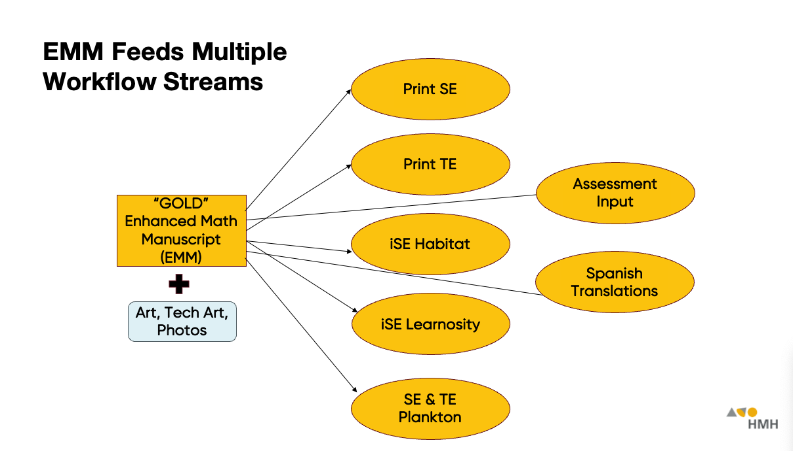
Module and Lesson Structure for Program - (The v2 story)

Into Math NL V2 and CA is based on Into Math V1 with significant edits. Lessons will be grouped by module, then by volume. Into Math NL V2 and CA will not have units. All content for Into Math NL V2 and CA will be contained in the EMMs. We will not be using tearsheets for reused V1 content.

How to Approach the Content – LXDV Guidelines and Resources
Ensure that manuscript meets the readability requirements for the grade level and content is presented in a grade-level appropriate manner.
A
Review these documents before starting development:

California Mathematics Framework
Please read the California Mathematics Framework Guidelines for general understanding. There are additional guidelines with specifics for how the Drivers of Investigation, Content Connections, and Standards of Mathematical Practice should appear in content. These will be linked in the guidelines at point-of-use.

Diversity, Equity, and Inclusion Guidelines
These guidelines are overriding guidelines. They are mindset guidelines and need to be considered and implemented in the composition of any piece of the Math Program. They should be considered in the broadest possible terms. That is, they govern everything from name selection in student-facing materials to selection of imagery to creation of art and tech art. Our goal is to have an approachable, friendly, accessible program in which every student can see themselves represented and every student can think of themselves as not only capable, but fluent in Mathematics.

See the Diversity, Equity, and Inclusion Guidelines for specifics on topics and how they should be represented in content.

NLv2/CA TOCs and Lesson Notes
The TOCs for the NLv2/CA program are in Excel spreadsheets located in subfolders of this folder. For each grade’s TOC, there is also a Word doc with notes for all new and revised lessons to guide the development of those lessons. For example, the screenshot below shows the TOC and lesson notes for Grade 4.

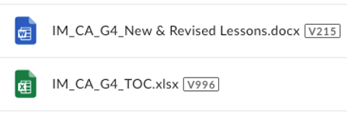

Detailed guidelines for using the TOCs and lesson notes can be found here. The following are important high-level points to keep in mind:

- The lesson notes don’t account for all revisions needed. The notes describe the revisions to each lesson’s instructional tasks that are required to meet California’s math content standards. The LXDV will need to make similar revisions to the lesson’s Quick Check and Practice On Your Own exercises so that the content of the tasks and exercises aligns. Moreover, additional revisions will be needed to meet quotas for coverage of California’s Standards for Mathematical Practice (SMPs), Drivers of Investigation (DIs), and Environmental Principles and Concepts (EP&Cs), and to address California’s social content guidelines (e.g., we can’t have problems about pizza or other foods that CA might deem unhealthy).
- The LXDV should query HMH if they have a question or concern about the TOCs or lesson notes. If something in the TOCs or lesson notes is unclear or doesn’t seem to make sense, the LXDV should reach out to HMH for clarification. Since the LXDV is looking at the content with a fresh set of eyes, it’s possible they will notice errors, ambiguities, or opportunities for improvement that were missed by HMH.

California Math Standards Breakouts Charts

The California Math Standards Breakouts Charts break down each grade level standard and provide the lesson and Task/SYL that hit the breakout. Access the grade level breakout chart as you cite and use standards when authoring to ensure your content meets the hit locations.

Reach out to your HMH contact if:
- Standard(s) listed for a lesson are inaccurate.
- Additional standards or hit locations can be cited for this lesson that are not documented in the Standards Breakout Chart

Quotas for Teaching Strategy/Teaching Support (Session-Level Only)
Guidelines for writing Multilingual Learners (ML), UDL, and Common Error supports in Spark Your Learning, Tasks, and Quick Check are referenced within those sections of the Lesson-Level Guidelines, however, refer to the following list for quotas and placement of the supports.

Be sure the following is true for the three types of supports:

- There is no more than 2 Teaching Strategies/Supports per either task or T&T.
- Each Teaching Strategy/Support box should identify the specific type of support.
- Common Error Support occurs only after a Task.
- Minimum of 1 Common Error Supports for lessons with 2–4 Tasks, and minimum of 2 Common Error Supports for lessons with 5+ Tasks.
- UDL Strategy occurs after a Task or with T&T.
- Minimum of 2 UDL Teaching Strategies per lesson.
- ML Strategy exists after SYL Discussions or SYL T&T.
- Minimum of 1 ML Strategy exists after a Task or with a T&T.
- ML Strategy exists with Review SYL.
- ML Strategy exists with Quick Check.

Make sure to pay close attention to print-to-digital parity, detailed in the guidelines at point-of-use.

Table of Contents and LXDv Notes
Side-by-Side : A visual representation comparing V1 to the EMM to NL V2 / CA (G4)
Sample EMM : A filled in example of a G4 EMM
EMM “Blank Templates” Folder
CA Standards
CCSS Standards

Workflow Schedule and Issues Tracker
- Into Math V2 / CA Schedule Smartsheet– should be updated when EMM is 100% complete and ready to be handed off to Comp.
- Issues Tracker - Please document all queries or issues so that consistent answers can be provided in a timely manner.
- EMM Checklist – Please fill out a checklist once each lesson EMM is completed, and post along with completed EMMs in the box folders.

Into Math V2 / CA Schedule Smartsheet
LXDv is responsible to documenting in the Smartsheet each of the following steps for each lesson:
- ⁠LXDV Creates Draft EMM
- ⁠LXDV Creates Final EMM

LXDV Creates Draft EMM – This can be marked as complete when all of the following has been done:
- EMM is completely filled out and ready for a PRS review (ready for HMH LXDs for the first modules in each grade.)
- All images have been requested or updated in the Image Tracker and all Specs #s recorded in the EMMs.

LXDV Creates Final EMM
- EMM is 100% complete.
- All items on the checklist have been confirmed as completed and EMM checklist is filled out and posted to box.
- Image work is complete.

HMH Project Specific Acronym list
- SE = Student Edition
- TE = Teacher Edition
- GM = Go Math
- OYO = On Your Own
- DL = direction line
- MP = More Practice or Mathematical Practices
- SMP= California Standards of Mathematical Practices
- DI= Differentiated Instruction OR DI=Drivers of Investigation
- Etc. [update]

Important Links

Reference Guidelines

- TOCs Guidelines for How to Use
- ML Guidelines
- UDL Guidelines
- Mathematical Language Routines (MLR) Guidelines
- Vocabulary Guidelines
- Learnosity Guidelines
- Pattern Guide for SYL and Tasks EMM DevelopmentCalifornia Mathematics Framework Guidelines
- SMP Guidelines
- Images Guidelines and Workflow
- Math IPACC Imagery (Illustrative Art versus) Tech Art
- Alt Text Guidelines
- Depth of Knowledge Documents
- DEI Guidelines
- Show Your Thinking Icons
- Manipulatives and Supporting Documents
  - GK Anomalies
  - GK-2 Digital Manipulatives
  - G3-5 Digital Manipulatives
  - G6-8 Digital Manipulatives
  - A1 Digital Manipulatives
  - CCSS Math Standards
  - Into Math Manipulative List
- Grades K-5 Megatrackers
  - Mod/Lesson Level
  - Item/Task Level
- Grades 6-A1 Megatrackers
  - Mod/Lesson Level
  - Item/Task Level

EMM Training Videos

Training Video Links | Purpose | When to Use
Plankton | The purpose of this training video is to give a brief overview about the Plankton platform, the available resources, and how it is being used within the EMM authoring process.. | Before beginning (or while) authoring:  - Spark Your Learning  - Instructional Tasks
Learnosity | The purpose of this training video is to give a brief overview about the Learnosity platform, the available resources, and how it is being used within the EMM authoring process. | Before beginning (or while) authoring:  - Quick Check  - Practice On Your Own
Multilingual & Universal Design Learning Supports  (ML/UDL) | The purpose of this training video is to give a brief overview about the Multilingual & Universal Design Learning Supports (ML/UDL), the available resources, and how they are being used within the EMM authoring process. | Before beginning (or while) authoring:  - Spark Your Learning  - Instructional Tasks  - Quick Check
Mathematical Language Routines  (MLRs) | The purpose of this training video is to give a brief overview about the Mathematical Language Routines (MLRs), the available resources, and how they are being used within the EMM authoring process. | Before beginning (or while) authoring:  - Spark Your Learning  - Instructional Tasks
Common Error Supports | The purpose of this training video is to give a brief overview about the Common Error Supports, the available resources, and how they are being used within the EMM authoring process. | Before beginning (or while) authoring:  - Spark Your Learning  - Instructional Tasks
Standards for Mathematical Practices  (SMPs) | The purpose of this training video is to give a brief overview about the Standards for Mathematical Practices (SMPs), the available resources, and how they are being used within the EMM authoring process. | Before beginning (or while) authoring:  - Instructional Tasks  - Practice On Your Own
Diversity, Equity, and Inclusion  (DEI) | The purpose of this training video is to give a brief overview about the Diversity, Equity, and Inclusion Guidelines (DEI), the available resources, and how they are being used within the EMM authoring process. | Throughout the Entire Lesson
Before You Teach | The purpose of this training video is to provide support on how to begin the authoring process for Before You Teach within the EMM. It will highlight the needed resources as well as provide examples of how to enter content within this section of the EMM. | Before beginning (or while) authoring:  - Before You Teach
Spark Your Learning  (SYL) | The purpose of this training video is to provide support on how to begin the authoring process for Spark Your Learning (SYL) within the EMM. It will highlight the needed resources as well as provide examples of how to enter content within this section of the EMM. | Before beginning (or while) authoring:  - Spark Your Learning
Tasks | The purpose of this training video is to provide support on how to begin the authoring process for the Instructional Tasks within the EMM. It will highlight the needed resources as well as provide examples of how to enter content within this section of the EMM. | Before beginning (or while) authoring:  - Instructional Tasks
Quick Check and Practice On Your Own | The purpose of this training video is to provide support on how to begin the authoring process for the Quick Check and Practice On Your Own within the EMM. It will highlight the needed resources as well as provide examples of how to enter content within these sections of the EMM. | Before beginning (or while) authoring:  - Quick Check  - Practice On Your Own

Lesson Level Guidelines

Page 1 and Before You Teach

Page 1
- Introduction
  - This is the recording keeping page that is for internal use only. Every lesson will include this table.
  - This page that ensures that the new content name/code marries up correctly with the source material. It also holds the metadata details for the lesson.
  - The first column is boilerplate.
  - The links to the V1 PDFs will be referenced throughout the rest of the guidelines, for all sections.

- Determine if content can be reused with edits or new content needs to be written.
- In “Grade” row, insert the correct grade number (or title for Algebra 1)
- In “Lesson” row, insert the correct lesson number in the format “#.#” such as 12.1.
- This can be found in the grade level ToC, column A “Mod/Lesson” in the TOC & LXDV Notes Box Folder.
- In “Lesson Title” row, insert the lesson title.
      - This can be found in the grade level ToC, column B “Title” in the TOC & LXDV Notes Box Folder.
        - Be sure to not use the titles in rows labeled “Module #”. We want lesson level titles here.
    - In “V1 Source Lesson(s) row, insert the correct lesson number in the format “#.#” such as 12.1.
      - This can be found in the grade level ToC, column C “Source” in the TOC & LXDV Notes Box Folder.. It is not necessary to include the NL designation.
- In “V1 TE PDF Lesson(s) Link” row, insert a hyperlink to the NL PDFs used as the base for this lesson.
  - PDFs for NL V1 are posted here: https://hmhco.box.com/s/qpknzvk75o7vmc6lbqx8p1tgcyg0ikzq
- Lesson Meaningful Description and Lesson Keywords need to be created and recorded in the MegaTracker.
  - In “Metadata: Lesson Meaningful Description” look at Descriptions and Keywords Guidelines.
  - In “Metadata: Lesson Keywords” look at Descriptions and Keywords Guidelines.
  - Links to MegaTracker to insert Meaningful Descriptions and Keywords for each lesson/module:
    - Grades K-5 Megatrackers
      - Mod/Lesson Level
      - Item/Task Level
    - Grades 6-A1 Megatrackers
      - Mod/Lesson Level
      - Item/Task Level

As you work through the EMM, update the page numbers in the table of contents section on page 1.
- Right click or control click on the chart.
  - Select “Update Field” (Desktop version) or “Update Table of Contents” (Online Version).
  - Select “Update Page Numbers Only” (Desktop version) or “Update Table of Contents” (Online Version).

Before You Teach

- Introduction
  - This is the teacher-facing planning page.
  - This page captures all the resources (standards, materials, etc.) that a teacher needs to gather or understand prior to teaching the lesson.
  - Boilerplate:
  - The heads of each section (denoted by the orange color).
  - “Digital Authoring Within:” under the Before You Teach head should always read “TBD.
  - Additional examples of boilerplate are identified under each subsection
- Determine if content can be reused with edits or new content needs to be written.
- For lessons that are revised (minor and major), much of this content will be reusable as is.
- For lessons that are new, this content will be new.

“What should I understand about the math?”

- Introduction
  - This is the teacher-facing lesson summary.
  - It explains what is covered in the lesson, and lives right next to the standards so the teacher understands the correlation between the two.
What should I understand about the math? is boilerplate (and bold)
- Determine if content can be reused with edits or new content needs to be written.
- For pick up or lightly revised lessons, the lesson summary can be reused from V1.
- For new lessons this content will be new.
- Steps for Reused Content
- Access the planning “A” page of the NL V1 from the lesson in the V1 TE PDFs Box Folder.
- Find the “What It Means to You,” “Using Mathematical Practices and Processes” and/or “About the Math” paragraph(s) at the bottom of the page, under Mathematical Progressions.
- Edit down the paragraph(s) to 2-3 bullet points that mirror the content of the standards.
- Remove “Students will,” “Students demonstrate,” or any other similar language.
- Steps for Revised Content
  - See above, “Steps for Reused Content”.
- Steps for New Content
- Open the New and Revised lessons within the TOC & LXDV Notes Folder to see the scope of the lesson.
- Refer to the language of the standards documented in the Scope & Sequence tab of the ToC spreadsheets for guidance.
- Write 2-3 bullets about the content of the lesson each beginning with a verb such as "Identify" or "Describe."
  - Bullets do not begin with “Students will,” “Students demonstrate,” or any other similar language as in V1.

“What will students learn in this lesson?”

Prior Learning

- This section comes from the A page of the NL V1 from the lesson via Box.
- Information from the first column titled “Prior Learning” in the Mathematical Progressions chart can be reused in this section.
- Do not include the previous lesson references in parenthesis.
- For Prior Learning, refer to the Achieve the Core Progressions. https://achievethecore.org/page/1118/coherence-map

THIS LESSON– National Layer

- Introduction
  - This is the Common Core standard(s) “hit” within the lesson.
  - The purpose of this table is to document what standards are covered within the lesson, and ensure full coverage,
  - None of the content is boilerplate, however it is narrowly focused because it is derived from a specific set of information.
  - In most cases the NL layer and California layer will be identical.
- Determine if content can be reused with edits or new content needs to be written.
- If a lesson is being reused from v1, use the TOC to ensure that the same standards apply. Do NOT just take standards from V1 TE PDFs. Use the TOC as the source of truth.
- The Learning Objective can often be reused and will match CA.
- The Language Objective steps/guidelines can be found here for each lesson and will match CA.
- Mathematical Practice can often be reused.

- Steps for Reused Content
Mathematical Standards
- Open the grade level TOC within the TOC & LXDV Notes Folder.
- Use the Table of Contents (TOC) to determine the standards for the lesson and which standards are Focus, Apply, and Introduce by using the columns labeled “Standards – Focus”, “Standards – Apply”, and “Standards – Introduce”.
- In the EMM, set in rows in order of Focus, Apply, and Introduce.
- Focus- a permutation of the standard is used for the parts hit within the lesson. Remove any parts of the standard not covered in the lesson and replace missing sections with ellipses.
- To avoid overset on Lesson Planning pages, Standards language should allow for ellipses.
- The Breakout Charts may be helpful when writing the abridged version of the Focus Standards and summarizing the Intro and Apply Standards.
- As of 12/12/2024, the K-A1 Breakout Charts are here on Box:
- https://hmhco.box.com/s/x9it4w30jsp40zt13msya3h3zvdwz1t6
- 01_Planning / 01_Program Experience (TOC, UX, Component) / 01_CA_NL V2 Table of Contents and Notes

- Apply and Introduce standards need to be paraphrased.
  - If there are lessons that require the same Apply or Introduce standard paraphrasing, be sure that the language is consistent for each lesson.
- Some standards include “For example...” this clarifying language (and other italicized clarifying language like it) will be needed at the module level but not at the lesson level.
Mathematical Practice
- Access the “A” planning page from the NL V1 lesson in the V1 TE PDFs Box Folder.
- The Mathematical Practice needs to be reviewed and revised. Many of the seven options will still apply. Consult the SMP guidelines to verify.
- Steps for Revised Content & New Content
Mathematical Standards
  - Follow same process as above.
Mathematical Practice
  - Follow same process as above.

THIS LESSON– California Layer

- Introduction
  - This is the California Math standard(s) “hit” within the lesson.
- Steps for Reused Content
CA Mathematical Standards
- Follow steps above to find the standards for the lesson using the TOC & LXDV Notes Folder.
- Open the grade level TOC within the TOC & LXDV Notes Folder.
- Add the CA Standards code in bold.
- If the standard is Apply or Introduce, use gray for the code and the paraphrased standards language.
CA Mathematical Framework
- Refer to the New and Revised lessons within the TOC & LXDV Notes Folder to see how the three parts of the CA Mathematics Framework needs to be constructed.
- This framework creates a sentence, so please mirror the punctuation of a comma after the Drivers of Investigation and last Standard of Mathematical Practice. Put a period after the Content Connections.
  - The CA Mathematics Framework needs to be reviewed and revised.
  - Drivers of Investigation, consult the CA Framework Guidelines.
  - Standards of Mathematical Practice, consult the CA Framework Guidelines.
  - Content Connections, consult the CA Framework Guidelines.
- Steps for Revised & New Content
Mathematical Standards
    - See above, “Steps for Reused Content”.
CA Mathematical Framework
    - See above, “Steps for Reused Content”.

Learning Objective

- Steps for Reused Content
- Access the “A” planning page from the NL V1 lesson within the TOC & LXDV Notes Folder
- The Learning Objective remains the Learning Objective in pick up lessons.
- Steps for Revised Content
- See above, “Steps for Reused Content”
- Steps for New Content
  - Review the standards and skills students are expected to practice in this lesson using the TOC & LXDV Notes Folder. Some new lessons already have the Learning Objective written for you in the respective grades’ LXDV notes.

Language Objective
- Access the steps/guidelines for the language objective for reused, revised, and new lessons here.

Future Connections

- Steps for Reused Content
- This section comes from the A page of the NL V1 from the lesson via Box.
- Information from the third column titled “Future Connections” in the Mathematical Progressions chart can be reused in this section.
- Do not include the future lesson references in parenthesis.
- Steps for Revised Content
  - See above, “Steps for Reused Content”
- Steps for New Content
  - New lessons will require content to be written.
  - For Future Connections, refer to the Achieve the Core Progressions.

What tools do I need?
- Introduction
  - This shows the materials needed throughout the lesson.
  - The heads within the table are boilerplate.
- Determine if content can be reused with edits or new content needs to be written.
  - For reused content, “Materials per student” can be reused and quantities added.
  - Document which manipulatives were used for the lesson in the appropriate grade band Lesson-Level Megatracker (K-5 or 6-A1). List all materials selected using the dropdown in the Manipulatives column.
- Steps for Reused Content
  - Access the planning “A” page of the NL V1 lesson in the V1 TE PDFs Box Folder.
  - Find the Materials.
  - Review the content of the lesson to determine which materials are used individually and which are used in pairs. Add the materials to the first or second column of the materials chart in EMM accordingly.
  - Use the Quantity per kit column of the Into Math Manipulatives List to determine the quantity of items and whether it is per student or per pair of students using a class of 25 students.
  - Identify the amount needed by reviewing the numbers used in the problems.
    - List the items in alphabetical order.
- Round up the greatest number to the nearest 5. For instance, instead of 18 color tiles, use 20 color tiles in the list. Since the premium kit has 2,200 counters, a class of 25 students can each have 75 two-color counters, however, since the Premium Kit contains 900 base-ten units, 95 base-ten units would need to be shared among pairs of students.
- Document which manipulatives were used for the lesson in the appropriate grade band Lesson-Level Megatracker (K-5 or 6-A1). List all materials selected using the dropdown in the Manipulatives column.
- Use correct IM v2 grade band Digital Manipulatives List within the Manipulatives and Supporting Documents Box Folder to determine which are listed in the lesson.
- Steps for Revised Content
  - See above, “Steps for Reused Content”.
- Steps for New Content
  - Use the TOC & LXDV Notes Folder to determine the content of the lesson. Use the Into Math Manipulatives List to choose materials that could support students in learning the content.
  - Document which manipulatives were used for the lesson in the appropriate grade band Lesson-Level Megatracker (K-5 or 6-A1). List all materials selected using the dropdown in the Manipulatives column.
- Printable Materials
  - If the material is a printable, indicate in parenthesis, after the title of the printable
    - ex. Coordinate Planes (Printable)
  - List of Printable Materials is found in the Teacher Resource Masters

Vocabulary

- Introduction
  - This shows the new or review vocabulary lesson
  - The heads within the table are boilerplate.
  - If there are no new or review vocabulary terms, include N/A in the rows of the table.
- Determine if content can be reused with edits or new content needs to be written.
  - In most cases, the vocab for CA will match the NL V1.
- Steps for Reused Content
  - Access the Vocabulary Tracker
  - Insert the words for your lesson from the tracker.
- Steps for Revised Content
  - See above, “Steps for Reused Content”
- Steps for New Content
  - See above, “Steps for Reused Content

What is the flow of the Essential Session?

- Introduction
  - This shows the progression of learning goals and routines throughout the lesson.
  - The heads within the table are boilerplate.
  - “Insights Available: Use your data insights and classroom observations to determine students' individualized next steps.” Is boilerplate.
- Steps for Placing Content
  - Insert Learning Goal in the first row.

- Skip the Get Ready – Learn – Assess section until all tasks are authored.
  - Once all tasks are authored, insert the MLR routine(s) used in each task (including Spark Your Learning and Turn & Talk) in the chart.
    - When inserting the MLR routines for each task, continue to list out the tasks in the rows. If there are more rows than needed, place N/A in empty rows.
    - The word “routine” should remain lowercase. If there are multiple routines, include the word “and” between them and remove the parenthesis around the (s) at the end. Example: Three Reads and Compare and Connect routines
  - Learning Goal routine (Get Ready & Assess Column) and Quick Check (Assess Column) routine are boilerplate.
6-8, A1 “Learn” 45MIN Considerations
6-8 and A1 lessons are ~90min (or 2 days).  We will place a “45 MIN” label after a Task to provide a suggested pause on instruction so teachers have an idea of where to stop after one 45min class (or 1 day).  - Review the length of the SYL and Tasks. Determine after which Task to place the "45 MIN” suggestion.  - Place "45 MIN” in the row after this Task under the “Learn” column. (In the EMM screenshot shown, the author decided the 45 MIN suggested pause is most appropriate after Task 2, but you decide where to place this suggested pause based on the length of SYL and Tasks.) | Print Prototype Example:  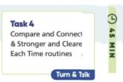EMM Placement:  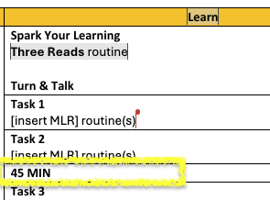

How do I provide data-driven individualized support?
- Introduction
  - This section provides teachers with differentiated instruction and practice opportunities to support their students.
  - This section is almost entirely boilerplate except for the end of the sentence in brackets.
- Steps for Placing Content
  - Use the language from the Learning Goal (I Can statement) to complete the sentences under Differentiated Instruction and Practice Opportunities.
    - Do not include “I can” from the statement. Use the action from the statement to complete the sentence.

Learning Goal (Beginning and End)

- Introduction
- The Learning Goal is set in place so that both teachers and students have a clear understanding of the content to be learned in an upcoming lesson.
- The Learning Goal is the “I can” statement which appears in several sections throughout the lesson level pages: Before You Teach, Get Ready (Set Learning Goals), and Assess (Learning Goal).
    - The Learning Goal is a student facing goal for the lesson and must be written in student friendly verbiage. Before pasting the Learning Goal into the template, review the verbiage to determine if it is written in a student-friendly manner. Revise the Learning Goal, if needed, to ensure it includes words that are appropriate for the grade-level audience.
- The Learning Goal will need to be placed within the respective sections of the Lesson-Level EMM.
- Determine if content can be reused from V1 (Reused Content), reused from V1 with edits (Revised Content) or new content that needs to be written from Scratch (New Content).
- The Learning Goal will remain the same each time it is referenced throughout a lesson. Each lesson will have its own Learning Goal.
- The Learning Goal will either be reused from a source lesson in NLv1, or in cases where the lesson has been revised or is entirely new, you will need to reference the correct grade level New & Revised Lesson Notes in the TOC Box Folder.
- To determine whether or not the Learning Goal is coming from a source lesson in NLV1 or the LXDV notes, refer to the specific grade level Table of Contents (Excel Sheet) within the TOC Box Folder.
- Steps for Reused Content
  - Refer to the specific grade level Table of Contents within the TOC Box Folder and find Column D. If a lesson is marked as PU, it is considered a “pick-up,” and the Learning Goal can be found directly in the source lesson of the NLV1 Teacher Edition:
    - Open the corresponding source lesson in the Teacher Edition.
    - Locate the Lesson Opener page (A page)
    - Locate and copy the content from under Lesson Focus and Coherence
- Finding and Placing the Learning Goal:
- In the Lesson Focus and Coherence section of the source lesson’s A page, copy the I Can Objective. Determine if the language in the I Can objective is appropriate for the grade level. If so, copy it. If not, revise it so that the language is student-friendly.
- Once copied, go back to the EMM and scroll down near the bottom of the Before You Teach section and paste the I Can Objective from the source lesson into the Learning Goal box on the EMM.
- Scroll down to the first blue Get Ready (Set Learning Goals) section of the EMM. This section consists of both digital and print Student Content, as well as TE Teacher Notes for both Classcraft and Print.
- Separate platforms are being used depending on grade band to author the digital content:
Grade Level Considerations
GK-A1
Digital student content is authored using the Plankton platform.

All static and interactive content is referred to as block types/patterns.

  - Student Content Row 1:
    - For digital authoring: The Plankton Block Type (Grades K–A1) for the first row of the table will always be Text/Paragraph. You can paste the Learning Goal under Student Content in the top row.
    - For print authoring: any black text will be student facing and will need to be placed in print.
  - Student Content Row 2:
    - For digital authoring: The Plankton Block Type (Grades K-2) for the second row will be Multiple Choice.
    - The pattern (Grades 3-A1) for the second row will always be Drawing Interaction with a global image set as the background for students to use to assess themselves.
    - The text in gray pertains to the Plankton patterns and is boilerplate for the Learning Goal section.
    - The text in black is student facing in both print and digital. The “I can” statement will change from lesson to lesson. The direction line will be boilerplate and varies between grade bands:

Grade Level Considerations
GK-2 | G3-A1
Choose how well you understand this learning goal: | Rate yourself on this learning goal:
Students will use multiple choice to select the image that represents how well they understand the learning goal. | Students are given text set in the background of a drawing interaction and they are expected to fill in a circle to choose the statement that represents their understanding.
    - The format for how the content should appear in print will also appear in the first column on the left. For the learning goal, the digital pattern will vary between the grade bands, but the way the content will appear in print will be the same: multiple choice.
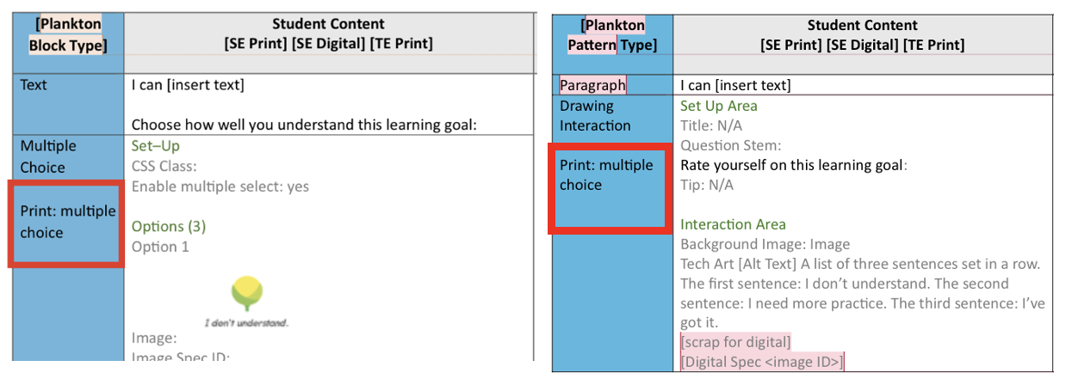
  - Teacher Notes:
    - Text here should be boilerplate and is already placed in the EMM except for the #2:
    - To author #2, insert text that supports all learners with the language within the I Can statement
      - Example: Clarify the meaning of [text] and [text] to help with student understanding.
      - In the brackets, include words from the I Can statement that students may need clarified before understanding what the I Can statement is expecting them to do.
- Scroll down to the second blue Assess (Learning Goal) section of the EMM. This section is set up the same way as the Get Ready section above.
  - Student Content Row 1:
    - For digital authoring: the Plankton Block Type for the first row of the table will always be Text or Paragraph. You can paste the Learning Goal under Student Content in the top row.
    - For print authoring: any black text will be student facing and will need to be placed in print.
  - Student Content Row 2:
    - For digital authoring: The Plankton Block Type (Grades K-2) for the second row will be Multiple Choice.
    - The pattern (Grades 3-A1) for the second row will always be Drawing Interaction with a global image set as the background for students to use to assess themselves. The text in gray pertains to the Plankton and is boilerplate for the Learning Goal section.
    - For print authoring: any black text will be student facing and will need to be placed in print.
  - Teacher Notes:
- Text here should be boilerplate and is already placed in the EMM. No changes are needed.
- Refer to screenshots for where the content should be picked up from and placed by viewing the POC Full v1 to v2 Side-by-Side Chart or G4 12.1 v1 to EMM Side-by-Side Chart.
- Steps for Revised Content
- Revising the Learning Goal:
- The Learning Goal has already been created for revised/new lessons. You can copy it directly from the New & Revised Lesson Notes (note: the Learning Goal is labeled as the “I Can” statement within the LXDV notes).
- Paste the I Can Statement copied from the LXDV notes into the Learning Goal box at the bottom of the Before You Teach section on the EMM.
- Scroll through the EMM to paste the same Learning Goal in both the Get Ready (Set Learning Goals) and Assess (Learning Goal) sections.
  - Refer to content in Step 3 for filling out the Plankton Block Type/Pattern, Student Content, and Teacher Notes section of the EMM. You will place the revised content in the same way you placed reused content above.
- Steps for New Content
- Creating the Learning Goal:
- If for any reason the Learning Goal has NOT been provided in the LXDV notes, please review the content of the revisions in the LXDV notes as well as the source lesson listed in Column C in the Table of Contents (Excel Sheet) and create a Learning Goal that aligns with the content.

Resources: recap of links that were used throughout the above steps
- Table of Contents
- LXDV Notes
- Side-by-Side in Chart
- ML Guidelines

Spark Your Learning and Review Spark Your Learning

Step 1: Introducing the Spark Your Learning Components
The Spark Your Learning sets up learning for the lesson. The objective of the Spark Your Learning item is to bridge mathematical content, elicit and address common errors, activate prior knowledge, and require student perseverance. The SYL is focused on foundational prerequisite learning. We should not be introducing any new skills but rather the skills needed to support the introduction of the new skill. Review the table below that shows the components of the SYL. Then move to step 2-6 for guidance on how to write each component.

SYL Component & Description | V2 Sample
Spark Your Learning Item: The SYL item appears in the SE and the TE. The SYL item is either picked up from V1 or created new for V2. The SYL item must be solvable using only skills from previous lessons or courses, because the SYL item comes before the tasks in the lesson where new skills are taught. | 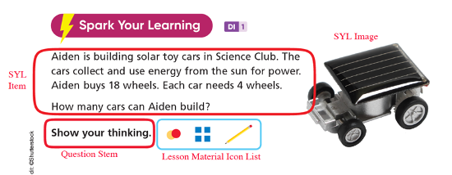  Student facing SYL format changes based on grade level.
Spark Discussions Chart: The Spark Discussions Chart appears in the TE and is new to V2. The Spark Discussions Chart includes a narrative review of the SYL common error, a student example of the common error with teacher scripting and a student example of a correct strategy with teacher scripting. | 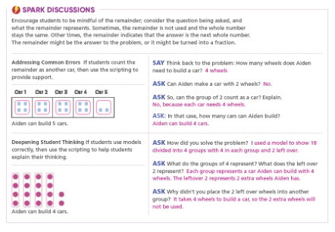
Spark Your Learning Turn and Talk: The SYL V2 Turn and Talk appears in the TE for all grades. The Spark Your Learning Turn and Talk will not appear in print in GK. The Turn and Talk provides students with a brief opportunity to discuss their ideas and key learnings and for students to be accountable for explaining their strategies. | 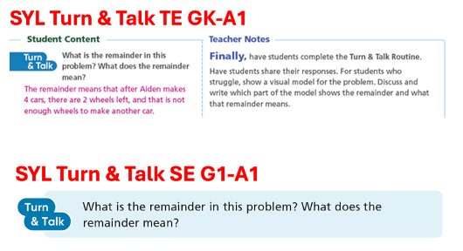
ML Teaching Strategy: The ML Teaching Strategies are multilingual learner supports for teachers that appears in the TE. These supports may be found within the SYL Spark Discussions Chart, SYL Turn and Talk and/or Review Spark Your Learning. | 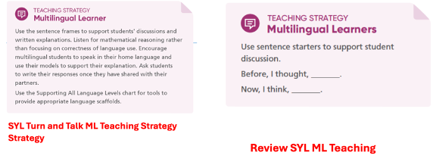
ML Proficiency Chart: The ML Proficiency Chart appears in the TE. The ML Proficiency Chart is a tool to help teachers support multilingual learners through the SYL item. | 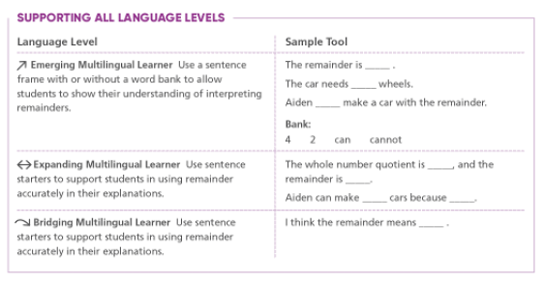
Review Spark Your Learning: The Review Spark Your Learning appears in the SE and TE. The review of the SYL provides all students with a unique question that connects back to the SYL. | 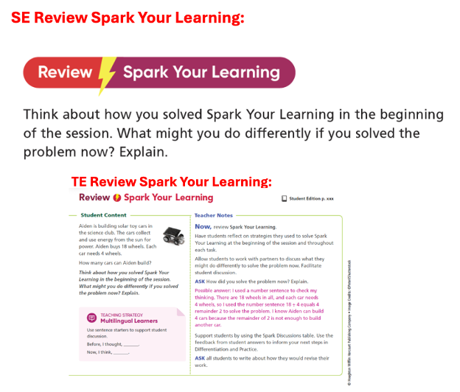

Step 2: Learning about the V2 Lesson
Before beginning the SYL editing and authoring process refer to the grade level Table of Contents and grade level New & Revised Lesson Document, which can be found in the Table of Contents Folder.

New & Revised Lesson Document: The new and revised lesson document contains any notes or guidance for the V2 lesson. This document should be read for each lesson prior to any work being complete. Specific instructions may be indicated for each lesson. Follow all instructions listed in this document.

TOC Column D: Refer to the specific grade level Table of Contents and find column D. Column D indicates if the new V2 lesson is a PU, REV, COMB, SPLIT, or NEW lesson.

- If column D indicates a COMB lesson, this means the new V2 lesson has two V1 source lessons. In these cases, the New and Revised Lesson Document will tell you which source lesson to pick-up the SYL item from or if a new SYL is needed.

TOC Column L: Refer to the specific grade level Table of Contents and find column L. Column L indicates if content can be reused from V1 with edits or new content needs to be written from scratch.

- If column L is blank, there is an existing SYL in V1 that needs to be evaluated to determine if certain components of V1 can be reused along, with the new additions that will need to be added. For grade K-8 move to step 3. For Algebra 1 move to step 4.

- If column L indicates a Y for a lesson, then a new SYL needs to be created and ALL components will need to be written from scratch, move to step 5.

Step 3: Evaluating and Editing the V1 Components of a K-8 SYL
In this step you will locate and review all the V1 SYL components of the K-8 source lesson in the V1 Teacher Edition. The source lesson is identified in the grade level Table of Contents column C. The SYL developer will be evaluating the existing V1 SYL item, turn and talk, common error, and common strategy, to determine if these existing SYL components can be reused with edits and new scripting in V2. The developer will need the Teacher Edition of the V1 source lesson along with the grade level New and Revised Lesson Document and the grade level Table of Contents. Follow any special instructions, if given, in the New and Revised Lesson Document.

3a) Evaluate the V1 SYL Item: To evaluate the V1 SYL item for V2 criteria ask the following questions about the SYL item:
  - Does the SYL item elicit the common errors identified for this lesson?
  - Is the context of the SYL item culturally sensitive, keeping in mind the background of all students?
  - Does the SYL match the suggested time completion for the grade band from the start of the item to the conclusion of the Turn and Talk?
    - K-2: 5-10 minutes
    - 3-5: 10-15 minutes
    - 6-A1: About 15 minutes
  - Is the SYL item solvable using multiple strategies and approaches? This includes but is not limited to drawings, models, and manipulatives, allowing for critical thinking and a deeper understanding.
  - Does the SYL item have multiple entry points, allowing for students to share their initial thinking and strategies in various ways?
  - Does the SYL item build upon student’s current understanding, allowing students to address any previous unfinished learning and bridge content between topics?
  - Is the SYL item context high interest, yet appropriate to the grade level of students, including interesting and relatable mathematical context, to aid in student engagement, understanding, and transferability?
- Is the SYL item context thoughtful to students of all backgrounds?
  - Does the SYL item lend itself to a rich follow-up discussion to set up students to be accountable for explaining their strategies?
  - Confirm the SYL item does not introduce new formal vocabulary.
  - If applicable, condense the SYL into a single paragraph. The entire V2 SYL Item will be above the student workspace. There will be no write on lines or questions below the student workspace.
  - All V2 question stems will be “Show your thinking”. If the developer wants to incorporate the existing V1 question stem, it needs to be worked into the V2 item.

Make any necessary edits to the V1 SYL item to align with the V2 criteria given above. Refer to the DEI Guidelines for further guidance on appropriate context.

For the existing SYL V1 Image:

Proactive Image Review & Lesson Scan (throughout EMM)
• Ensure that all images are checked prior to including them in the EMM using the following steps:
• Open the Image Guidelines and Workflow in Box.
• Filter by lesson in the CA Image Tracker Smartsheet.
• K-5 LXDV Dashboard Link
• 6-A1 LXDV Dashboard Link
• Review each item in the lesson and approve (or reject) IPAAC suggestions.
• Note the spec information, and alt text in each SYL and Task of the EMM.

3b) Review the V1 Common Error and Strategy: Review the V1 SYL Common Error and Strategy which can be found on the Spark Your Learning Student Sample Page. The SYL should be used first and foremost to elicit common errors of the focus standard if possible. Use your best judgement to ensure the common error and strategy match the SYL item and any edits that have been made to the item. Make edits to the V1 common error and strategy as needed based on any change made to the SYL item. Choose one common strategy to highlight in the spark discussion chart. If a new common error needs to be identified for the V2 lesson once edits have been made to the SYL item, use the instructions in step 5b and 5e and the Common Error Spreadsheet.

3c) Evaluate the V1 SYL Turn and Talk: The grades K-2 V1 SYL Turn and Talk can be found in the TE in the right-hand column of the persevere section of the SYL page. The grades 3-8 V1 SYL Turn and Talk can be found in the SE on the student SYL page.

To evaluate the V1 SYL Turn and Talk for V2 criteria ask the following questions about the SYL turn and talk question:

- Does the turn and talk question match any edits made to the SYL task?
- Is this question a follow-up question to the SYL extending the task?
- Can the question be connected to the common error identified for the SYL?
- Does this question set up the expectation and support for students to be accountable for explaining their strategies?

Make any necessary changes to the V1 SYL turn and talk to align with the V2 criteria given above.

GK | GK-2
Turn & Talks will NOT appear in print in GK on the SE page. (This also applies to Turn and Talks following tasks.)  The right side of this table also includes considerations involving GK. | Turn & Talks are only available in the teacher wrap of the v1 TE but are student facing. Please create a teacher prompt to be used on the right side of the EMM (teacher guide).  Example of student facing T&T in TE wrap:  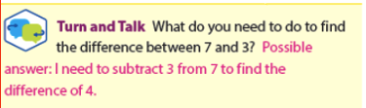  Example of newly created Teacher facing Prompt for Teacher Guide section of EMM:  Encourage children to think about what difference means and how they can represent it to find the difference between 7 and 3.

V1 Teacher Facing | New Student Facing | Considerations
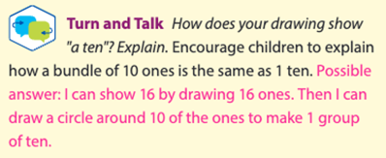 | How can you draw to show a ten? | -Language is simple and to the point  -Students should have an understanding of the words used.  -Not text-heavy and is not overwhelming for a student who cannot read.

3d) Lesson Materials: Make note of the lesson materials listed for the lesson in V1 on TE Before You Teach Page in the lesson focus and coherence section. Make note of the existing V1 SYL Show Your Thinking Icons. Make sure any edits made to the V1 SYL item still match the lesson materials. The lesson materials will be recorded in a later step.

Now, move to step 6 to place the above components in the EMM and author new scripting.

Step 4: Evaluating and Editing the V1 Components of an A1 SYL
In this step you will locate and review all the V1 SYL components of the A1 source lesson in the V1 Teacher Edition. The source lesson is identified in the A1 Table of Contents column C. The SYL developer will be evaluating the existing V1 SYL item, turn and talk, common error, and common strategy, to determine if these existing SYL components can be reused with edits and new scripting in V2. The developer will need the Teacher Edition of the V1 source lesson, the SYL Classroom Presentation Tools, along with the A1 New and Revised Lesson Document and the A1 Table of Contents.

4a) Review, Evaluate and Condense the V1 A1 SYL Item: The V1 Algebra 1 SYL has a different format than grades K-8. The first step to condensing and evaluating the Algebra 1 V1 SYL is to review the SYL item in its entirety. This includes the SYL on the SE SYL page and the corresponding Spark You Learning Classroom Presentation Tool located in the lesson resources on ED. The SYL should be condensed into one single paragraph, with one focus question. All information students need to solve should be contained in the paragraph. In addition to the reformatting of the V1 SYL, the SYL needs to meet the following V2 criteria:
  - The SYL item elicits the common errors identified for this lesson and align to a lesson focus standard.
  - The context of the SYL item is culturally sensitive, keeping in mind the background of all students.
  - The SYL is projected to take students about 15 minutes to complete.
  - The SYL item is solvable using multiple strategies and approaches. This includes but is not limited to drawings, models, and manipulatives, allowing for critical thinking and a deeper understanding.
  - The SYL item has multiple entry points, allowing for students to share their initial thinking and strategies in various ways.
  - The SYL item builds upon student’s current understanding, allowing students to address any previous unfinished learning and bridge content between topics.
  - The SYL item context is high interest, yet appropriate to the grade level of students, including interesting and relatable mathematical context, to aid in student engagement, understanding, and transferability.
- The SYL item context is thoughtful to students of all backgrounds.
  - The SYL item lends itself to a rich follow-up discussion to set up students to be accountable for explaining their strategies.
  - The SYL item does not introduce new formal vocabulary.
  - The entire V2 SYL item will be above the student workspace. There will be no write on lines or questions below the student workspace.
  - The question stem is “Show your thinking”.

Reformat the existing A1 SYL and make any necessary edits to the V1 A1 SYL item to align with the V2 criteria given above. Refer to DEI Guidelines for further guidance on appropriate context.

For the existing SYL V1 Image:

Proactive Image Review & Lesson Scan (throughout EMM)
• Ensure that all images are checked prior to including them in the EMM using the following steps:
• Open the Image Guidelines and Workflow in Box.
• Filter by lesson in the CA Image Tracker Smartsheet.
• K-5 LXDV Dashboard Link
• 6-A1 LXDV Dashboard Link
• Review each item in the lesson and approve (or reject) IPAAC suggestions.
• Note the spec information, and alt text in each SYL and Task of the EMM.

4b) Review the Algebra 1 V1 Common Error and Strategy: Review the V1 SYL Common Error and Strategy which can be found on the Spark Your Learning Student Sample Page. The SYL should be used first and foremost to elicit common errors of the focus standard if possible. Use your best judgement to ensure the common error and strategy match the SYL item and any edits that have been made to the item. Make edits to the V1 common error and strategy as needed. Choose one common strategy to highlight in the spark discussion chart. If a new common error needs to be identified for the V2 lesson once edits have been made to the SYL item, use the instructions in step 5b and 5e and the Common Error Spreadsheet.

4c) Evaluate the Algebra 1 V1 SYL Turn and Talk: The A1 V1 SYL Turn and Talk can be found in the SE on the student SYL page. The A1 Turn and Talk will also need to be condensed into a single focus question format rather than multiple parts.

Condense and evaluate the V1 SYL Turn and Talk for V2 criteria ask the following questions about the SYL turn and talk question:
- Does the turn and talk question match any edits made to the SYL task?
- Is this question a follow-up question to the SYL extending the task?
- Can the question be connected to the common error identified for the SYL?
- Does this question set up the expectation and support for students to be accountable for explaining their strategies?

Make any necessary changes to the V1 SYL turn and talk to align with the V2 criteria given above.

4d) Lesson Materials: Make note of the lesson materials listed for the lesson in V1 on TE Before You Teach Page in the lesson focus and coherence section. Make note of the existing V1 SYL Show Your Thinking Icons. Make sure any edits made to the V1 SYL item still match the lesson materials. The lesson materials will be recorded in a later step.

Now, move to step 6 to place the above components in the EMM and author new scripting.

Step 5: Authoring a New SYL from Scratch
When authoring a new SYL refer to the specific grade level Table of Contents to review the lesson placement in the module along with the New & Revised Lesson Document. Reference column D to determine if the lesson is a REV or a NEW lesson for V2.

- If the lesson is a REV (revised) lesson, review the V1 source lesson/lessons including the lesson objectives. Also review the grade level New & Revised Lesson document that can be found in the grade level TOC folder, on any notes and changes.
- If the lesson is a new lesson being created, review the grade level New & Revised Lesson document about the new lesson being created.

Some of the steps below may be outlined in the New and Revised Lesson Document. Make sure to check this document before moving to Step 5a.

5a) Lesson Focus Standards: After reviewing the lesson placement and any New & Revised Lesson Document notes, identify and review the lesson Focus standards to select the best standard to align the SYL item too. The SYL should be used first and foremost to elicit common errors of the focus standard if possible.

    - When at least one of the lesson Focus standards have been addressed previously in the module, or in a prior module as a Focus standard, that focus standard should be chosen to align the new SYL item to. If more than one focus standard is addressed previously in the module or in a previous module, pick the standard that best serves as a set-up for the lesson, based on the lesson objectives.

    - If the lesson Focus standards have not been previously addressed in the current module, or a previous module as a Focus standard, but the standard has been covered as an introduction standard, that standard should be chosen to align the SYL to. Refer to the lesson objectives of the lesson the standard is introduced in and the lesson objectives of the lesson you are authoring for to guide the SYL item.

    - If a Focus standard of the lesson has NOT been previously covered in the module, or a previous module as an introduction or Focus standard, reference the Common Core Coherence Guide, to determine which prerequisite standard maps into the Focus standard. Chose a standard that best serves as a set-up for the lesson.

    - If the Focus standard of the lesson repeats in multiple lessons throughout the module, this standard should be chosen to align the SYL item to. Use the lesson objectives of the previous and current lesson to help guide the SYL item in these cases.

5b) Common Error Look-Up: Once a standard has been chosen to align the SYL to, review all common errors for the SYL standard using the Common Error Spreadsheet. Keep these errors in mind as you author the SYL item. Choose one common error that will be highlighted in the spark discussions chart.

5c) Author the SYL Item: Author an SYL item that aligns to the standard identified in step 5a. Following the criteria below when authoring a new task. Also refer to DEI Guidelines for further guidance on appropriate context.
- The SYL item should elicit the common errors identified.
- The estimated time of completion for an entire lesson is 45 minutes. The SYL should take students and teacher an appropriate amount of time to complete from the start of the SYL to the conclusion of the Turn and Talk. SYL time suggestions per grade band are:
    - K-2: 5-10 minutes
    - 3-5: 10-15 minutes
    - 6-A1: About 15 minutes

- The SYL item should be solvable using multiple strategies and approaches, including drawings, models, realia, and manipulatives, to allow for critical thinking and a deeper understanding.

- The SYL item should have multiple entry points, allowing for students to share their initial thinking and strategies in various ways.

- The SYL item should be built upon student’s current understanding, allowing students to address any previous unfinished learning and bridge content between topics.

- The SYL item should be of high interest to students, including interesting and relatable mathematical context, to aide in student engagement, understanding, and transferability.

- The SYL item should lend itself to a rich follow-up discussion with follow-up questions to set up students to be accountable for explaining their strategies.

- The SYL item should be about a grade level appropriate context. Ex) Avoid asking kindergarteners about screen time, per the latest research pointing to less screen time for younger children.

- The SYL item context should be thoughtful to students of all backgrounds. Think about the diverse background of all students when choosing a context. Not all students live in a house being remodeled. Avoid problems around calories. Build appropriate thoughtful context around STEAM concepts. Ex) Measurement, length, temperature, data collection, building things, rainfall, plants, and animals.

- The SYL item should not formally introduce new vocabulary so that the teacher can attend to students’ mathematical ideas rather than correcting new vocabulary.

- If possible, the SYL item should be an open-ended task, that has more than one solution. The task should be accessible by all students, yet that extends to sufficient depth that all students remain challenged (a high ceiling low floor threshold).

    - The SYL Item should end with the question stem “Show your thinking”.

- Find the solution or one possible solution to the SYL item.

5d) Write the Common Strategy: Author a common strategy based on the SYL created. The common strategy is a sample of a student solving the SYL correctly with an appropriate grade level skill or tool. The common strategy should include any corresponding images and a verbal description of the strategy. Author should provide scrap art for any images or models.

5e) Adapt the Common Error: Adapt the common error chosen in 5b in terms of the SYL item authored. The common error should include a student sample where the common error is being made. Images can be shown with the common error. Author should provide scrap art for the image needed.

5f) Confirm Lesson Materials: Confirm that the SYL item authored can be solved using the lesson materials listed on the TE Before You Teach Page and the Module Lesson Map Page. Determine Show Your Thinking Icons based on the lesson materials, and tool that would be helpful to solving the SYL.

5g) Author the SYL Turn and Talk: Author an SYL turn and talk question. The SYL turn and talk question should be a follow-up question to the SYL that extends the task and connects to the common error. The turn and talk question should also set up the expectation and support for students to be accountable for explaining their strategies. The turn and talk should be an appropriate grade level reading level and word count.

Now, move to step 6 to place the above components in the EMM and author new scripting.

Step 6: Placing Spark Your Learning Components and Authoring New Scripting in the EMM:
6a) Placing the Lesson Materials from step 3d, 4d or 5f:
- Find the Spark Your Learning (Whole-Class Session: Learn) table of the EMM. Fill in the Suggested materials for workspace based on step 3d, 4d, or 5f, which is based on the lesson materials listed on the TE Before You Teach Page, the Module Lesson Map Page, and the existing Show Your Thinking Icons. View the grade level Show Your Thinking Document for the appropriate grade level to view the V2 icons.
  - Gr K Show your Thinking Icons
  - G 1-2 Show Your Thinking Icons
  - Gr 3-5 SE Show your Thinking Icons
  - Gr 6-A1 Show your Thinking Icons
  - Find the file name from the grade level Show your Thinking Icons Documents linked above, of the show your thinking icons to be included in the SYL.
- Paste the file names of the Show Your Thinking Icons from the document into the EMM Spark Your Learning (Whole-Class Session: Learn) suggested materials for workspace.
- Determine the grouping students will participate in when completing the spark. This grouping can be determined by the amount of materials available. Sparks are typically done in pairs or small groups. If enough materials are available from the K-8 Kit for materials and the content allows, students should work in pairs.

6b) Placing the Spark Your Learning Item & Image:
  - Copy the Spark Your Learning Item from step 3a, 4a, or 5c.
  - Find the Spark Your Learning (Whole-Class Session: Learn) section of the EMM. Paste the SYL Item from step 3a, 4a, or 5c into the Student Content (Print & Digital) TE Student View (Print) paragraph box as the paragraph text. Include a screenshot of any SYL images in the image box. Note that in Plankton (Grades K-2), the block type is referred to as text instead of paragraph.
    - The digital pattern/block type has been predetermined and is boilerplate within the EMM.
    - GK: Text, Drawing Interaction (image will be set in the background of Drawing Interaction)
    - G1-2: Text, Image (if applicable), Drawing Interaction
    - G3-A1: Paragraph, Image (if applicable), Drawing Interaction
    - The EMM has an additional section in the pink left-hand column for how the content will appear in print. This has also been predetermined. The content will appear as open space in print.
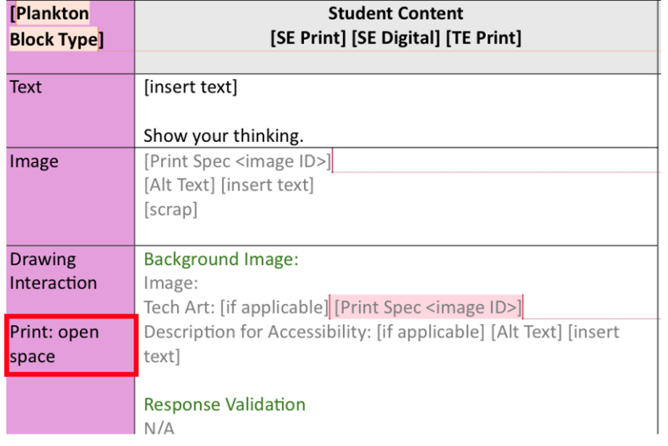
  - Find the Spark Your Learning Turn and Talk section of the EMM. Paste the SYL Item from step 3a, 4a or 5c into the Student Content/Student View (TE) paragraph box as the paragraph text. Include a screenshot of any SYL images in the image box.
    - The digital interaction will be Speech Text for the T&T
    - The print content will be set to an open space 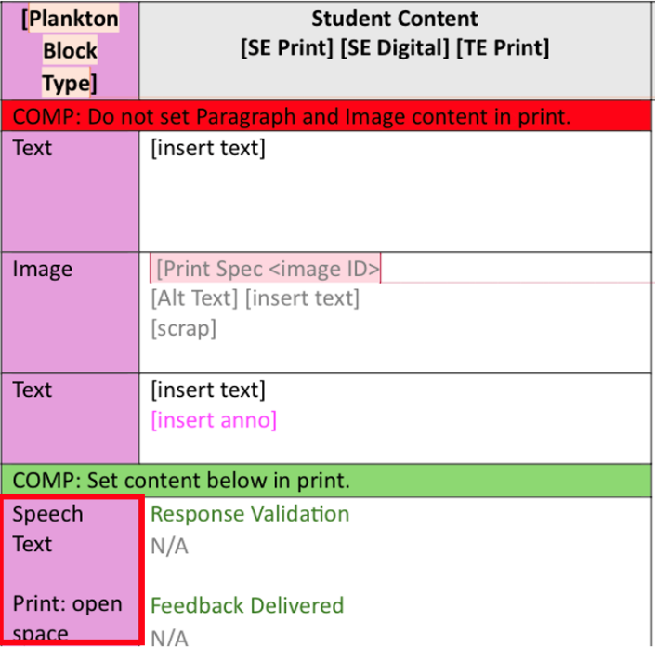
  - Find the Review Spark Your Learning (Whole-Class Session: Learn) section of the EMM. Paste the SYL Item from step 3a , 4a, or 5c into the Student Content (Print/Digital) Student View (TE) paragraph box as the paragraph text. Include a screenshot of any SYL images in the image box.

6c) Determine if Three Reads routine applies to the SYL & Write Scripting:
- Determine if the Three Reads MLR routine is appropriate for the SYL item. Review the MLR Guidelines for more information on the Three Reads routine.
  - If the Three Reads routine applies, find the Get Ready, Learn, Assess Table in the Before You Teach section of the EMM and fill in Three Reads where it states [insert MLR]. Then find the Spark Your Learning (Whole-Class Session: Learn) section of the EMM. In the TE Teacher Notes (Print and Classcraft) fill in the [text] section of the given Three Reads routine. View the MLR Guidelines for additional guidance on this text.
  - If the Three Reads routine does NOT apply for the SYL item, no MLR will be used. Find the Get Ready, Learn, Assess Table in the Before You Teach section of the EMM and delete the [insert MLR] bracket. Then find the Spark Your Learning (Whole-Class Session: Learn) section of the EMM. Delete the Three Reads routine text (shown in the red box on the screenshot below). These lines of text should be replaced with:
    - “Now, have students read the problem. Make sure they understand what the problem is asking them to do.”

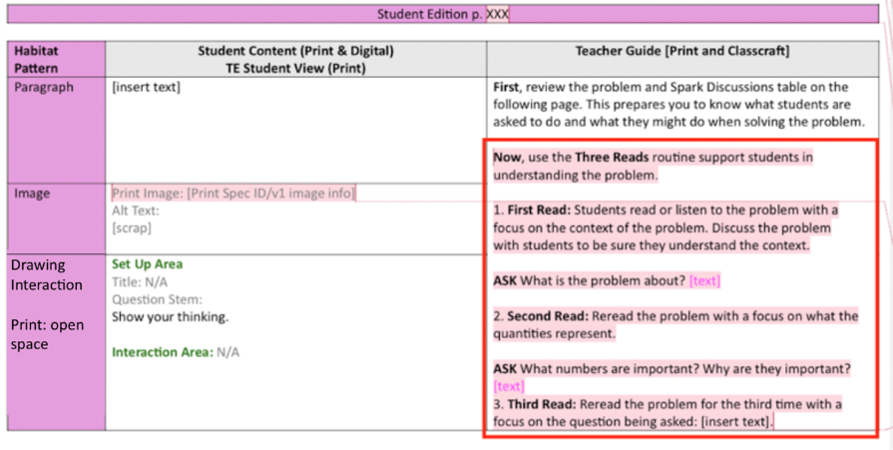

6d) Placing the Spark Discussions Chart Components & Write Scripting:
- Find the Spark Discussions (TE Only) section of EMM. This chart addresses the common error and the common strategy for the specific SYL, using the common error from step 3b, 4b or 5e. The Spark Discussions Chart has a narrative overview section, an Addressing Commons Errors Section, and a Deepen Student Thinking Section.
- The first section of the Spark Discussions Chart is a narrative overview of the common error for the SYL. We are not prescribing strategies to solve in this narrative. Place the narrative text in the 2nd row, under Spark Discussions. Th narrative should be 1-3 sentences elaborating on the error and any helpful professional development for teachers. We are not including strategies in this section.
- Paste the common error from step 3b, 4b or 5e in the Addressing Common Error section of the Spark Discussions chart. Use the boilerplate sentence: “Students [might/may] [insert text]. Use the scripting to provide support for this error.
- Include a screen shot of any images in the scrap bracket.
- Author teacher scripting around the common error helping students understand and correct the error for further learning. This scripting should indicate exactly how a teacher could intervene when a common error occurs, while highlighting the common error. Include this text in the Addressing Common Error Scripting portion of the table.
- Paste the strategy from step 3b, 4b or 5d in the Deepen Student Thinking section of the Spark Discussions chart. Use the boilerplate text:
  - “If students [Insert text] correctly, then use the scripting to help students explain their thinking.”
Include a screen shot of any images in the scrap bracket.
- Author teacher scripting around the strategy and how students solved correctly and avoided making the common error. Share examples of what acceptable and encouraged strategies might look like that still highlight the common error. Include this text in the Deepen Student Thinking Scripting portion of the table.

6e) Placing the Turn and Talk & Write Scripting:
  - Find the Spark Your Learning Turn and Talk section of EMM. Paste the Turn and Talk question from step 3c, 4c, or 5g in the drawing interaction of the table as the question stem. Include a possible answer in pink font under the turn and talk question.
- Author Teacher Notes (TE) around the SYL Turn and Talk. Use the boilerplate text: “Finally, have students complete the Turn & Talk routine.
[Insert text]"

6f) Authoring SYL ML Teacher Strategy:
- Find the Teaching Strategy Multilingual Learners section of EMM after the SYL Turn and Talk.
- Reference the ML guidelines for guidance to write this ML Teacher Strategy.

6g) Authoring ML Proficiency Chart:
- Find the Supporting All Language Learners section of EMM, under the SYL Teaching Strategy Multilingual Learners section.
- Reference the ML guidelines for guidance to write the Text for this table.

6h) Authoring Review Spark Your Learning Scripting:
  - Find the Review Spark Your Learning (Whole-Class Session: Learn) section of the EMM.
  - In the Speech Text box author a specific unique Review Spark Your Learning question stem.
    - Note that in Plankton (Grades K-2), the unique Review Spark Your Learning “question stem” belongs in a text Plankton Block Type. It does not belong in the Speech Text box for this grade band, although the Speech Text row should still be indicated on the EMM. It can be left as is with the predetermined Response Validation and Feedback sections set as N/A.
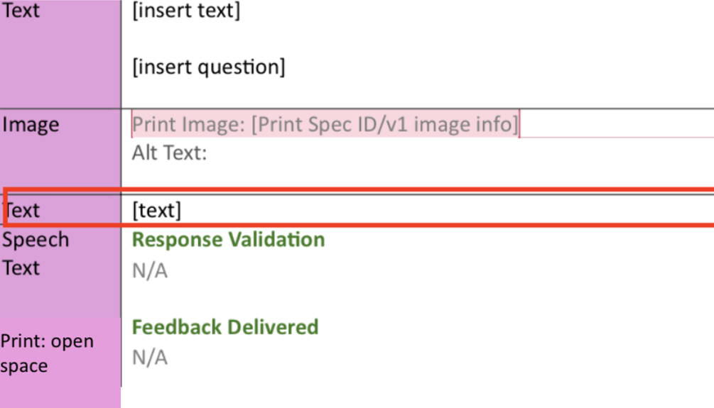
  - The Review Spark Your Learning question stem should draw on some aspect of the lesson’s common error, new learning, interesting discovery, or math efficiency. The question stem should ensure the understanding from the SYL has been addressed and any learning gaps are closed. This question stem should be unique for each lesson.
  - In the Teacher Notes (TE) box author teacher facing language in the ASK format that will help the teacher guide the students through the Review Spark Your Learning question stem. This language should help teachers scaffold through the review spark your learning question stem. Sample Review Spark Your Learning question stems have been given in the table.
SYL Aspect Drawn On | Review Spark Your Learning SAMPLE Question Stem | Teacher Facing language  ASK format SAMPLE
Common Error | Are all remainders interpreted in the same way? How do you know how to interpret a remainder based on the context of a problem? | ASK: Are all remainders handled the same way?  ASK: What are some ways to interpret a remainder?  ASK: How does the context of a problem impact the remainder? What are some examples?
Interesting Discover | If two problems have the same remainder, will the meaning of the remainder always be the same? | ASK: Do we always round down when interpreting remainders? What is a situation where we round down to interpret a remainder?  ASK: Do we always round up when interpreting remainders? What is a situation where we round up to interpret a remainder?
Math Efficiency | Think about how you solved Spark Your Learning in the Beginning of the Session. What might you do differently if you solved now? | ASK: How did you solve the problem in the beginning of the lesson? What strategies did you find helpful?  ASK: All students how they would revise their work.

6i) Authoring Review SYL ML Teacher Strategy:
- Find the Teaching Strategy Multilingual Learners section of EMM after the Review Spark Your Learning
- Reference the ML guidelines for guidance to write this ML Teacher Strategy.

Step 7: Resources
- Grade Level Table of Contents
- CA Mathematical Practice Standard 1
- Common Core Coherence Guide
- Common Error Spreadsheet
- Gr 3-5 SE Show your Thinking Icons
- Gr 6-A1 Show your Thinking Icons
- ML Guidlines
- MLR Guidelines
- DEI Guidelines

Tasks
Introduction
  - The Instructional Tasks serve as guided practice learning opportunities where students engage with the concepts and skills taught within the lesson.
  - The purpose of the instructional tasks is to provide students with stepped out practice opportunities that support students in moving toward independent application of the lesson objective.
  - The Instructional Tasks will need to be placed within the respective sections of the Lesson Level EMM:
    - Setting Up Tasks & Placing Content (Whole-Class Session: Learn)
      - Plankton Block Types/Patterns
      - Student Content
      - Teacher Notes
    - Teaching Strategy for Tasks
    - Turn & Talk
    - Teaching Strategy for Turn & Talk
    - Depth of Knowledge
    - Continuing with Task 2 and Beyond
  - Any text preexisting on the EMM in the Task section can be considered boilerplate. Any content that needs to be inserted or changed around the boilerplate will appear inside of brackets.

Reuse, Revise, or New?
- Determine if content can be reused from V1 (Reused Content), reused from V1 with edits (Revised Content) or new content that needs to be written from scratch (New Content).
  - Instructional Tasks will either be reused from a source lesson in NLv1, or in cases where the task has been revised or is entirely new, you will need to reference the LXDV notes for that specific grade (Word Document).
- If an Instructional Task needs to be created, please refer to the LXDV notes for that specific lesson and use the Justification tab from the Table of Contents to ensure that necessary content is included.
  - To determine whether or not the Instructional Task is reused, revised, or new, refer to Column D in the specific grade level Table of Contents (Excel Sheet).
- Highlighted cells indicate that something in that lesson has been modified, and you can find more information on those Instructional Tasks using the LXDV notes.

Finding Reused Content
    - Lessons that have Instructional Tasks that are reused will be marked as “PU” (pick-up) in Column D in the Table of Contents and will not be highlighted.
    - Column C will list a source lesson.
      - Navigate to the source lesson listed in the TOC by using the v1 Into Math National TEs.
      - Task 1 will start on the second page if there is a Spark Your Learning. If there is no Spark Your Learning, Task 1 will start on the first page.
      - All tasks from the source lesson should be included unless otherwise indicated in the LXDV notes.
      - There are some grade level considerations listed below regarding reused Instructional Tasks:

Grade Level Considerations
GK | G1-A1
Task 1 comes from the problem with the orange car with 1 inside in the source lesson.   | Task 1 comes from the problem with the green arrow with 1 inside in the source lesson.
Each additional task will be indicated in the source lesson with a different symbol and a number.   | Each additional task will be indicated in the source lesson with the green arrow and a number.
Multiple tasks (up to 4) will come from the Build Understanding section.  If multiple tasks share a direction line, they will become a single task. For example, if Task 1 and Task 2 both share a direction line, together they will become Task 1.  Use the GK Anomaly guide to help support when tasks need to be combined. | Task 1 typically comes from the Build Understanding section in the source lesson, and Task 2 comes from the Step It Out section in the source lesson. (In some lessons in v1, both Task 1 and Task 2 will come from Step It Out.)

      - Please note that some tasks that are being reused may still need to be revised so that there is a parity with print. More information below in the Student Content section.
    - Tasks that are being reused may also need to be revised or replaced due to CEID and/or California Environmental concerns.
      - New or revised tasks should try to cover underrepresented or harder to cover SMPs and/or DIs (SMP.3, 5-8 as well and/or DI 2 or DI 3)
      - See CEID guidelines and/or California Environmental Guidelines for guidance on whether a task needs to be revised or replaced.
    - Each task will have its own table within the EMM. There are several task sections (4 sections or 6 sections depending on grade level) preset within the EMM, but some lessons will not require all of the task sections due to a lower amount of tasks. Please DO NOT DELETE the additional task sections that you do not use. Please insert N/A into the unused task boxes.
    - Depending on the grade, one task may have several lettered parts (A, B, C, D, etc.) Each part should have its own row and pattern in the EMM. (see Grade Level Considerations below.)

Grade Level Considerations
GK | G1-A1
The Instructional Tasks are typically represented with an image. There is only one question for students to answer. | The Instructional Tasks typically require students to answer a series of parts leading up to answering the initial question. The typical structure is as follows:  Problem/Direction line  Part A  Part B  Part C (and so on and so forth until all steps of the problem are complete)

    - Information for the Instructional Task section of the EMM will come from both the student page in the v1 TE, as well as the teacher wrap.
Finding Revised Content
    - When the Table of Contents indicates a lesson requires content revision, Column D will indicate “REV” or “COMB” (revised, combined) and Column C will indicate the source lesson(s) to be revised from NLv1 or another HMH source.
      - If content is revised from v1, you will need to reference the Into Math National TEs.
      - If content is revised from another HMH source, that source will be linked for you within the Table of Contents.
    - Task information regarding specific revisions can be found in the LXDV notes. LXDV notes may also reference another lesson from which content may be adopted in order to revise the indicated lesson.
Finding or Authoring New Content
    - When the Table of Contents indicates a lesson requires new content, Column D will indicate “NEW.”
    - Refer to the grade level LXDV notes to determine what content standards the newly authored lesson will need to target. Some of the new lesson tasks have been previously authored into the LXDV notes. At other times in the LXDV notes, specific references are made to what needs to be included in the newly authored lesson.

Setting Up Tasks & Placing Content
- Find the Whole-Class Session: Learn section in the EMM. This entire first section is dedicated to Task 1.
- Use the SE Bookmap tab of the grade level TOC for page number to fill in the page number.
- The next section of the EMM is broken down into three columns:
1. Plankton Block Type/Pattern (with Print Content)
2. Student Content
3. Teacher Content
    - Plankton Block Type/Pattern: The first column in the table indicates the type of Plankton Block Type/pattern that will be needed for digital authoring. Use the Pattern Guide for SYL and Tasks EMM Development and the standards in the grade level TOC to determine the type of block type/pattern used for each part of an individual Instructional Task.

Grade Level Considerations
GK-A1
Digital student content is authored using the Plankton platform.

All static and interactive content is referred to as block types/patterns.

      - With Print Content: In the same left-hand column that the block type/pattern is listed, we also need to accommodate for how the content will appear in print.
      - Parity with print is important to keep in mind, with the idea that students should produce the same answer in both formats.
        - In cases where a student may use a Drop Down pattern in Grades 3-A1, the print content may appear on a write on line or fill in box. A word bank is not always necessary to include in print depending on the amount of space on a page.
      - Content may appear in print in the following ways:
        - Write on Line (WOL)
        - Fill in Box (FIB)
        - Multiple Choice
        - Open Space
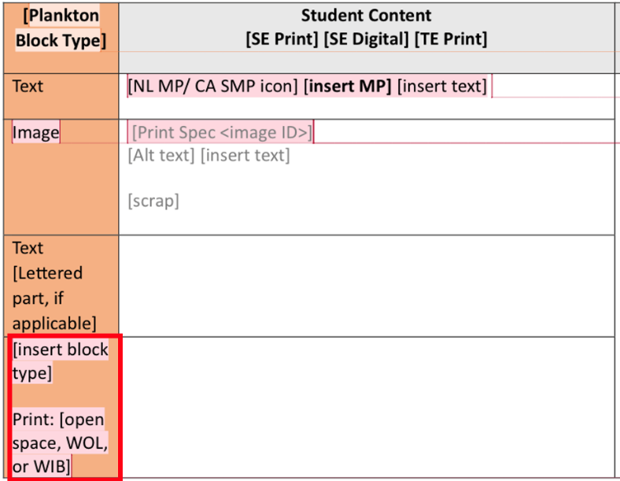
- Student Content: The second column in the table includes lesson content for both print and digital. The actual lesson content is the same for both modes, but digital-specific considerations are included here. Gray text refers to digital-specific considerations and require you to input information needed within the Plankton Block Type/pattern when necessary. You can find the input fields for each pattern in the Pattern Guide for SYL and Tasks EMM Development. Black text is student facing text which will appear both on the digital activity as well as the print Student Edition.
- The Plankton Block Type/Pattern, and the Student Content go hand-in-hand.
- The pattern for each item may vary, but each row will consist of a Set up Area and Interaction Area.
Setting Up Tasks
Grade Level Considerations
GK | G1-A1
If direction lines for up to 2 tasks are grouped together in v1, it becomes a single task.  When applicable, each image should be its own pattern in its own row in the EMM within the task. | Each task remains as a singular task with lettered steps.  Each step of the task should be its own pattern in its own row in the EMM within the task.
Row 1 will always be dedicated to the direction line using the text block type in Plankton. This is either new or a reused task from v1.  Row 2 usually begins with the Drawing Interaction. | Row 1 begins with the Text (Plankton Block Type) or Paragraph ( pattern), and the Student Content includes the task that is being reused from v1. We referred to this above as the Problem/Direction line and is the first part of the task structure:  Problem  Bolded Direction Line (if applicable)  Part A  Part B  Part C (and so on and so forth until all steps of the problem are complete)  For G1-2 in Plankton, the Problem will be in its own text row. This will appear as the “opener screen”  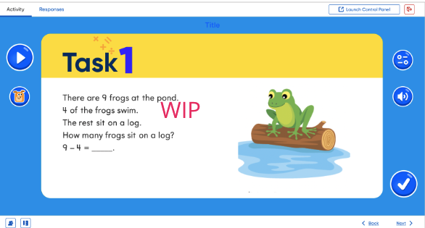  For G1-2 in Plankton, the bolded letter parts will be in their own text row. They will appear on individual screens.  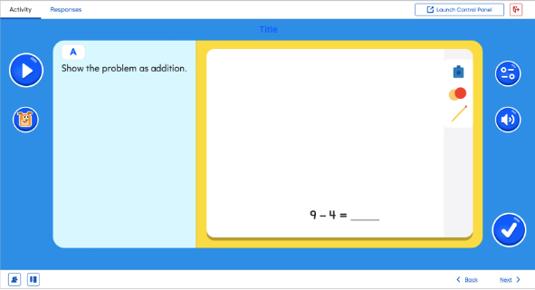  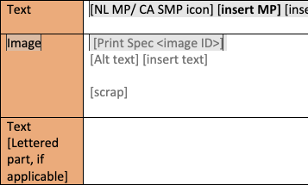  For G3-A1, the direction line will appear in the paragraph interaction in its own row. The lettered parts will be authored within their respective patterns using the “Question Stem” section of the pattern chosen.
Pick up the story at the bottom of the v1 SE page to serve as the direction line. | Plankton: Pick up the problem next to the numbered task on the SE page to serve as the direction line using text block type.  For G3-A1: Pick up the problem next to the numbered task on the SE page to serve as the Question Stem within any pattern.
 | In other rows, the direction line or question stem should start with the bolded letter if referencing the stepped-out parts of the problem.

Grade Level Considerations
G1-2
Occasionally in G1 and G2, there are no lettered steps. In this case, the direction line would be the actual problem in whichever pattern you chose to represent the question. The example shows a task with no lettered steps in Grade 1. The EMM inputs show that the direction line for this task was put into a text block type in Row 1, and the content of this this task was put into a Drawing Interaction in row 2. (The drawing interaction was chosen here because part of the standard is for students to write numbers.)
While there is not a lettered step for the last fill in the blank, this would need to be put in a third row with the fill in the blank block type and the specific input fields for that block type (found in the interaction guide.)

No lettered steps | EMM inputs
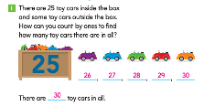 | 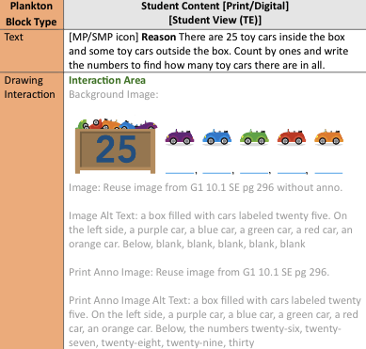

- When including math symbols for any grade, please author those using latex.
      - In Plankton, latex is found using the text block type. Latex is ${}_{}^{x^{2}}{}$ here.
      - For G3–A1, latex can be authored into the question stem of the pattern by choosing fx.
      - For grades that require more complex math symbols and equations use the Equation Text Editor in lieu of Paragraph. For additional information, refer to the Pattern Guide for SYL and Tasks EMM Development.

EMM Input Fields
- Ensure that all images are checked prior to including them in the EMM using the following steps:

Image Review
- Open the Image Guidelines and Workflow in Box.
- Filter by lesson in the CA Image Tracker Smartsheet.
- K-5 LXDV Dashboard Link
- 6-A1 LXDV Dashboard Link
- Review each item in the lesson and approve (or reject) IPAAC suggestions.
- Note the spec information, and alt text in each Task of the EMM.

- Once the image has been checked and approved, the image information in green below should be entered in its own row, unless it is part of the background image within the Drawing Interaction or as options given in a Multiple Choice or Drag and Drop. If it is part of the block type/pattern, the following formation is needed as part of the input fields in the EMM:
  - Print Image: enter the original v1 source file info: grade number, module number, lesson number, and page number. Include note to not include anno with the image.
  - Alt Text: provide written alt text for the image that is being used. Use Alt Text guidelines for more information.
  - Include a scrap image from print to indicate the exact image being reused. Include note to not include anno with the image.
  - Anno Print Tech Art/Image: same source information as Background Image, but include anno
  - Anno Print Tech Art/Image Alt Text: provide written alt text for the image that is being used including the anno.
  - Add additional rows in the Task section to continue with either the bolded direction line (may require a Drawing Interaction) or the bolded letters that indicate each stepped-out part of the Instructional Task (Plankton block types/ patterns will vary based on the kind of question):
    - Bolded Direction Line (if applicable)
    - Part A (in its own row)
    - Part B (in its own row)
    - Part C (in its own row... and so on and so forth until all steps of the problem are complete)
- The specific inputs of other various Plankton block types/patterns vary. More information about the input fields and what they require can be found in the respective interaction guides.
    - The information entered in the input fields in black text will also be used in print. Gray text is specific to digital inputs.
    - Place any anno that would require students to insert an answer in brackets: [answer]

- Continue to include the reused content from v1 by including in each row of the EMM. Each part of the task should have its own row and Plankton block type/pattern.
- If there are additional rows for Plankton block types/patterns that are unused, please place N/A into the row to indicate there is no more information to go there.

Parity with Print: Please note that some tasks that are being reused may still need to be revised so that there is a parity with print. Some examples of this are as follows:

Reused Content | V2 EMM | Rationale
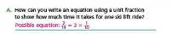 | 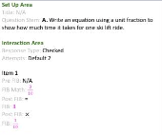 | This question is stated in a way that expects students to provide an explanation (How can you...) but the standard for this lesson does not require students to offer explanations.  The revised version is more direct.
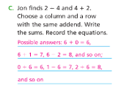 | Set Up Area  Title: N/A  Question Stem: C. Jon finds 2 – 4 and 4 + 2. Choose a column and a row with the same addend. Write the sums. Record the equations.  Interaction Area  Response Type: Checked  Attempts: Default 2  Item 1 Pre FIB: N/A  FIB: 6  Post FIB: +  Item 2 Pre FIB: N/A  FIB: 0  Post FIB: =  Item 3 Pre FIB: N/A  FIB: 6  Post FIB: N/A  Etc, etc. | Another consideration of parity to print is that in the digital version, due to digital constraints, we are giving students the math symbols:  ___ + ___ = ___  This also means that in print, we would need to give them the same blanks for them to fill in only the numbers so that it is a 1:1 match. The standards need to be considered here as well to ensure that the student is not expected to choose an operation, and that giving them that information is still in alignment with the standard.
For more information, please see Parity with Print for more information.

K-8/A1 Discrepancy in Step It Out Tasks: When applicable, blanks can be added to tasks to make them more in line with K-8. Blanks do not need to be added to every part of the Task, but one or two when able.
Example:
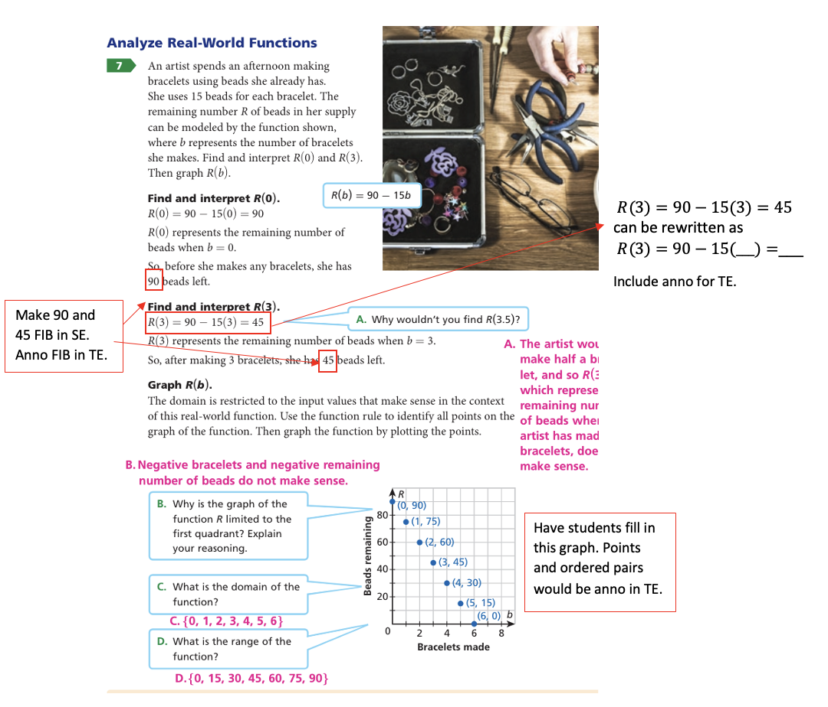

- Teacher Guide: The third column in the table includes teacher notes specific to the lesson.
- Parts of the Task Teacher Guide:
  - Consider
  - Start
  - Ask
  - Now
  - Next
  - Then
- Key:
  - Purple – must occur in this order
  - Green – can be moved in the flow to where it makes sense in the teachers supporting the students through the task. But all 5 pieces of the structure must be present for every task.
  - Blue – only occurs when an SMP / MP is being cited for that task.
- How to author the Parts of the Task Teacher Notes Text:
  - Black roman text is boilerplate and must be used.
  - Text in [brackets] indicate where content needs to be inserted by LXDv.
  - Keep the formatting as shown, so if text is bold, it should be bold in the EMM as well; if text is magenta, it should be magenta in the EMM as well.
  - Text in (parenthesis) is directions for the LXDv to populate the EMM.

- Consider
      - This is only included if the task is introducing new vocabulary. If the task is not in introducing new vocabulary, this should not appear in the Teacher Guide and the Teacher Guide content should start with the Start part. Delete ‘and [Vocabulary Term]’ if needed, or add an additional [Vocabulary Term] if needed, using the oxford comma.
      - Vocabulary Terms should have the same treatment as in the SE, so should be bold and highlighted in yellow.
      - (This part consists mostly of boilerplate. Insert the vocabulary terms where the brackets occur. These should be the same vocabulary terms for this task on the SE page.)

Consider using the Words to Learn routine for [Vocabulary Term] and [Vocabulary Term] when students need to describe their thinking. Or if there are ML students in your class, you may use the routine before instruction begins.

- Start
      - (This part consists mostly of boilerplate. However, an MLR needs to be selected and the name inserted where the brackets occur. See the MLR guidelines for guidance on how to select and cite an MLR.)

Start the task by making sure the students understand the problem. The [insert MLR] routine can help support students make sense of the problem.

- Ask
      - (On average there are usually 3-5 questions per task. The questions should either be a precursor for students working the task: set up the problem in the task or are guidance for students’ strategies or solutions; or should follow the students solving the problem in the task: follow-up or expand on the strategies used to the problem, or both.)

ASK [insert text]
[insert anno]

- Now
      - (This is boilerplate and should be moved within the content of the Teacher Notes, without edits, to where it makes sense in the flow of task. See guidance below for additional details.)

Now, have students solve the problem.

- Next
      - The [MP icon] is boilerplate even though it is in brackets. Insert the Mathematical Practice in the brackets. See the SMP/MP guidelines for how to select and cite the Mathematical Practice as well as how to author the supporting text. Move this within the content of the Teacher Notes to where it makes sense in the flow of task. If there isn’t an MP for this task, delete from the EMM.)

[MP icon] Next, have students use the Mathematical Practice: [insert MP].

[Insert supporting text]

- Then
      - (This part consists mostly of boilerplate. However, an MLR needs to be selected and the name inserted where the brackets occur. See the MLR guidelines for guidance on how to select and cite an MLR. The supporting text should help students reflect on the answers they got for the problem in the Task. Examples for the supporting text is found in the MLR Guidelines.)

Then, have students use the [insert MLR] routine to discuss their thinking.

[Insert supporting text]

- Notes on Ask and Now order
  - For placing the Ask and Now in the Teacher Notes content, base this on the task and the supporting teacher questions and determine when the teachers should ask questions in the flow of solving the task. This applies to questions from V1 re-used content and for newly written content. There are three options for the order of Ask and Now:
  - Note, Next might be interspersed with Ask and Now, depending on where the SMP/MP makes the most sense for that task.

- Example 1: Ask before Now
  - If the teacher questions (Ask) are needed to set up the problem in the task or are guidance for students’ strategies or solutions, structure the Teacher Guide Flow so that questions (Ask) come BEFORE the Now phrase, see example below.
- Example 2: Ask after Now
  - If the teacher questions (Ask) are follow-up or expand on the strategies used to the problem, structure the Teacher Notes content so that questions (Ask) come AFTER the Now phrase, see example below.
- Example 3: Now in the middle of Ask
  - If some of the teacher questions (Ask) are needed to set up the problem in the task or are guidance for students’ strategies or solutions AND some of the teacher questions (Ask) are follow-up or expand on the strategies used to the problem, the Teacher Notes content can be structured so that Now occurs in the middle of the questions (Ask), see example below.
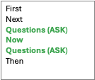

- Vocabulary (when applicable)
  - Vocabulary Guidelines
Grade Level Considerations
GK | G1-A1
Vocabulary only appears in the Teacher Wrap of the v1 Teacher Edition for the task that it connects with.    Vocabulary and definition of terms will not appear in the Student Content section.  Vocabulary (and definitions?) will only appear in the Teacher Notes section of the EMM. | If the lesson has new vocabulary, all new vocabulary terms need to be defined in the Task that has content that connects with the vocabulary term. Vocabulary terms can be introduced in 3 different ways:  1. In a Vocabulary Box  2. In a paragraph of running text before a task  3. In a part of the task itself  If you are re-using content from V1: Use the same option as was used in V1, keeping in mind page fit. If there will be overset as a result of re-using the V1 choice, you can choose to use one of the other options above.
 | If this is a new lesson: If there is room on the page, the preference should always be to use the Vocabulary Box. But if using the Vocabulary Box will result in page overset, use the content to decide whether to use option 2 “in running text before a task” or option 3 “in a part of the task itself”.
To Author in the EMM:
Option 1: Vocabulary Box:
Insert a row at point where you want the Vocabulary Box to appear in the content flow on the page or iSE.
Pattern Interaction Type: Aside
Plankton Block Type: Text
Put the content needed into the row Vocabulary Box
Option 2: Paragraph before Task
Put content needed in paragraph row. (Add a paragraph row where you want the vocabulary to occur if needed.)
Option 3: Part of Task
Select interaction(s) needed for task.
Add content needed in the question stem of the interaction.

Teaching Strategy for Tasks
  - The Turn and Talk for Task 1 requires ML Support. Please see the ML Guidelines for instructions on how to write this support.

  - The Turn and Talk for Task 2 and beyond requires either ML or UDL Support, but there is a minimum of 2 UDLs per lesson within the tasks. Please see the UDL Guidelines for instructions on how to write this support.

  - At least one Instructional Task will need to include a Common Error in the Teaching Strategy section following the task. The common error can focus on a practical error that students may make while solving the task. The minimum number of common error task teaching supports for each lesson is as followed:
    - Lessons with 2-4 tasks, should have at least 1 common error support.
    - Lessons with 5 or more tasks, should have at least 2 common error supports.
  - The Common Error Supports can only occur after a task, not within a task turn and talk. The Common Error Task Teaching Support connects the lesson task to a unique common error for the lesson standards found in the TOC. The common error identified in the Common Error Teaching Support is different from the common error identified in the SYL. The goal of the common error teaching support is to provide common error support for student work and to provide professional development for teachers. Common Error Teaching Support expands the content understanding with as wide a range of support as possible.
    - Review the Standards: Before authoring a Common Error Teaching Support refer to the specific grade level Table of Contents to review the lesson standards. After identifying the lesson standards, review all common errors that have been identified for the standard using the Common Error Spreadsheet.
    - Choose a Common Error: Choose a unique common error from the tracker, that has NOT been previously used in the specific lesson. The SYL Common Error from earlier in the lesson cannot be reused, and every common error support in a lesson must highlight a unique common error. The common error can repeat from another lesson, but let’s minimize this to not overuse the same common error throughout the module. You will need to edit the common error content from the spreadsheet to best fit and meet the needs of a task. The common error is NOT directly picked up from the spreadsheet. The spreadsheet is a reference point, to model the support around.
    - Author the Common Error Support: The Common Error Teaching Support can be authored:
      - in a Q&A or narrative style
      - have a sample question and then a sample answer
    - The important thing is that the style addresses the common error students may be making. The common error addresses what students are doing incorrectly and the teaching support addresses what we need to understand to support them once a common error is detected.
      - The Common Error Teaching Support MUST BE UNIQUE FOR THE TASK. Nothing can be verbatim or directly picked and used from the common error spreadsheet.
      - Common Error Teaching Supports must start with the boilerplate text: “Students [might/may] [insert text].
- Once authored, find the Teaching Strategy [Icon] box for the specific task which you will be incorporating a Common Error Teaching Support. Teaching Strategy [Icon] box is found after every Task (Whole-Class Session: Learn) in the EMM.
- In the Run-in head section fill-in “Common Error”.
- Fill in the text you authored from the steps above in the [text] section.
- Repeat this process for each Common Error Task Teaching Support needed to meet the minimum requirements.

  - There is a minimum of 2 UDLs per lesson within the tasks. You can add multiple teaching strategies to a task to ensure the correct amount is present within a lesson.

Turn & Talk
- The Turn & Talk may follow at the end of a task and gives students an opportunity to extend their thinking about a particular task and converse about it with a partner. Turn & Talks have their own table in the EMM. This table is organized the same way the Task table was.
- Each task will have its own corresponding Turn & Talk table within the EMM, but not every task requires a Turn & Talk. Please DO NOT DELETE the additional Turn & Talk sections that you do not use. Please insert N/A into the unused task boxes.

- Plankton
    - For Turn and Talks, the speech to text pattern will be the one that is commonly used. In Plankton, the question will need to exist within a text block type in its own row. In G3–A1, the question will exist within the question stem section in the Speech to Text pattern.
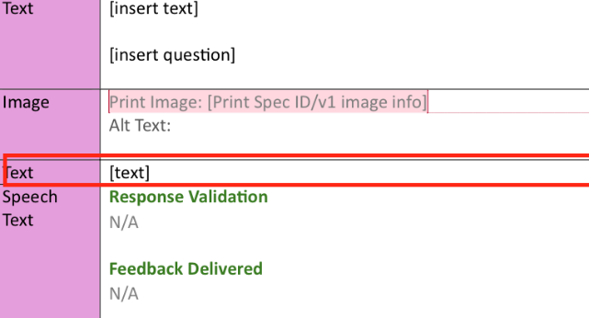 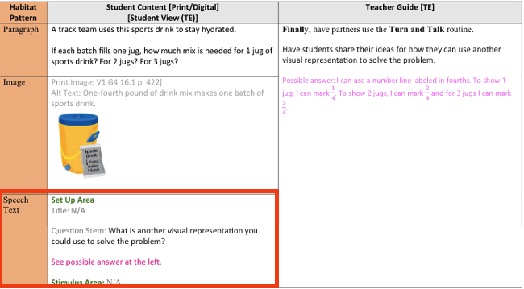 Plankton G3–A1

  - Student Content
    - To introduce the Turn and Talk, the original Task question (from the paragraph pattern) should be presented in the first row. This also includes any images that were found in v1, alt text which needs to be written for those images, Print Spec ID and the Digital Spec ID. Gray template text indicates digital or print specific needs.
      - If the image picked up from the original task has an image with anno, the anno needs to be turned to black text for students to reference. Make a note in the EMM to change anno to black.
    - The second row of the table introduces the Turn and Talk question. For lessons that are being picked up, the Turn and Talk can be found at the bottom of the SE page below the corresponding task (see Grade Level Considerations below.) If the content is revised/new, please pick up the Turn and Talk from the LXDV notes for that specific lesson.
    - The Turn and Talk question will be placed in the Question Stem. Anno will be used for print only.

Grade Level Considerations
GK | GK-2
Turn and Talks will NOT appear in print in GK on the SE page. (This also applies to Spark Your Learning Turn and Talks.)  The right side of this table also includes considerations involving GK. | Turn & Talks are only available in the teacher wrap of the v1 TE and may be presented in teacher facing language. For the EMM, please use the teacher-facing Turn and Talk as a guide and create a student-facing version that students will see on the digital platform only.

V1 Teacher Facing | New Student Facing | Considerations
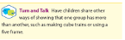 | How can you show one group has more? | - Language is simple and to the point.  - Students should have an understanding of the words used.  - Not text-heavy and is not overwhelming for a student who cannot read.

- Teacher Notes
  - Turn & Talk for the Teacher Notes text can be found next to the corresponding task in the source lesson TE wrap (see Grade Level Considerations below.)

Grade Level Considerations
GK-2
The newly written, student-facing Turn & Talk is represented in the Student Content, and the Teacher Notes section has the version picked up from the TE.
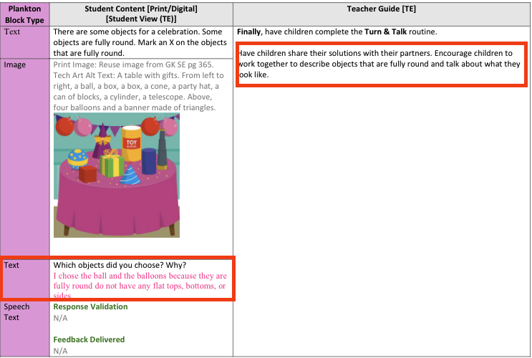

Teaching Strategy for Turn & Talk
- The Turn and Talk for Task 1 and beyond requires either ML or UDL Support, but there is a minimum of 2 UDLs per lesson within the tasks. Please see the UDL Guidelines for instructions on how to write this support. Please see the ML Guidelines for instructions on how to write ML support.

Depth of Knowledge Leveled Questions
- The Depth of Knowledge questions can be found under Task 1 in V1 for picked up lessons. If a lesson is revised or new, please refer to the Depth of Knowledge Documents. Additionally, you may use any of the reused content as a guide in creating new DOK leveled questions.

Continuing with Tasks 2 and Beyond
- Repeat the above steps to complete the section for Task 2, Task 3, etc. The number of tasks can differ between lessons and grade levels.

Grade Level Considerations
GK
The last task in the Step It Out section (usually TASK 4) is reserved for the Quick Check. If there are only 4 tasks, the last task should not be used in the task section of the EMM. Please refer to Quick Check Guidelines for more information.

- Each task and Turn & Talk (if applicable) will have a Teaching Strategy section.
- Only Task 1 includes Depth of Knowledge questions.
- Once all Task sections are complete, go up to the yellow Before You Teach section of the EMM to insert the MLR routines used for each task.
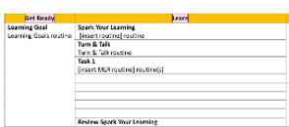
  - When inserting the MLR routines for each task, continue to list out the tasks in the rows. If there are more rows than needed, place N/A in empty rows.
  - The word “routine” should remain lowercase. If there are multiple routines, include the word “and” between them and remove the parenthesis around the (s) at the end. Example: Three Reads and Compare and Connect routines

Quick Check

(light green section)(Note title in NL V1 was Check Understanding)

Digital authoring within: Learnosity

- Introduction
  - The Quick Check section of the lesson is a formative assessment which checks students’ understanding of the material presented in the lesson’s instructional tasks.
  - This section should mirror the lesson’s objectives as well as the models, language, and format of the instructional tasks.
  - The work for this section can be done in 4 parts. In each part, you complete a task for all items in the section before moving to the next part, which will be completed for all items in the section. These parts are noted in PURPLE below:

- Determine if the content should be reused, revised, or authored new.
1st part – EVALUATION
  - Start by re-reading the purpose of the lesson.
  - Use the Into Math v1 TE.pdf to view the v1 aligned standards, I can statement, and instructional tasks for the lesson.
  - Read through the EMM.docx to take note of any updates to the standards, I Can statement, or instructional tasks.
    - Standards Make sure you understand exactly which part(s) of the standard(s) this lesson primarily focuses on as well as introduces or applies (changes from v1 will be shown in the IM_CA_G#_TOC.xlsx and the IM_CA_G#_New & Revised Lessons.docx as well).
    - I Can Statement (aka. Learning Goal) Understand this statement in tandem with the standards. Items in the lesson should reference some aspect of this statement.
    - Instructional Tasks Read and understand the steps of each task, taking special note of not only what is being asked, but how it is being asked, how the student is expected to respond, and the extent to which the student is taught the concepts or skills. Items in the lesson should mirror these aspects of the instructional tasks they follow.
  - Use the Manually Scored Items by Standard & Lesson.xlsx to decide if this lesson’s truncated standards (listed on the Before You Teach section of the EMM.docx) require a drawing/modeling interaction, an explain/justify interaction, or a choice of how to represent their thinking interaction (these are manually scored questions).
    - Rule The Quick Check component will NOT contain any manually scored items. Consider how you can assess the standard with an auto scorable interaction using the Math Item Specs Guide.pdf (see Use Cases and Scoring).
  - Notice how much space in on the page the current versions of the items in v1 occupy. Flag items in the component which could be removed (and allow for the remaining items to still cover the breadth and depth of the lesson’s instruction) in case items need to be discarded later to save space.
    - Ensure that the remaining, unflagged items will fully cover the concepts and skills introduced, focused on, and applied in the lesson’s tasks and aligned standards if cuts are made.
  - Build out the table on your EMM pages to match the number of items in this section currently in the v1 source lesson.
    - Input the item # shared by print and digital in the first column (multi-part items should use the item # for a paragraph stem and then the item number plus a letter a, b, c, etc. for each part)
    - Rule Please start numbering at 1 with Quick Check section.

- Steps for Reused Content (per item)
  - Due to the comprehensive guidelines around digital and print parity, it is likely that no questions in these sections will be reused as-is without any changes. Please refer to the step 4: Revised Content.

- Steps for Revised Content (per item)
2ND part – PARITY
  - Read the problem as it stands in the Into Math v1 TE.pdf. Evaluate the item on each of the following:
    - Does the item appropriately assess the standard?
      - Rule Quick Check items are assessment items and should strictly adhere to the standard language and scope. They should not ask students to perform a skill or apply knowledge beyond what the standard asks for.
    - Does the item reasonably match the format/structure in which students learned the skill or knowledge in an instructional task for the lesson?
    - Does the item require multiple distinct interactions within the single problem?
      - Example: student must give an answer AND explain, or student must give an answer AND show their work.
      - In these situations, the item will need to be reauthored as a multi-part item with multiple interactions and considerations in the following steps.
  - Once the item has been evaluated (and possibly adjusted) based on the previous 3 questions, it can now be considered for specific revisions.
  - Review the digital Check Understanding v1 item in Learnosity against how it appears in the Into Math v1 TE.pdf.
  - Use the Math Item Specs Guide.pdf (see Use Cases) to analyze the question type and understand parity between print and digital (see Digital & Print Parity) while answering each of the following:
    - Which question type would be used in Learnosity to represent the item?
      - The question type chosen in v1 may still be appropriate in many situations.
      - Add your chosen Learnosity question type to the second column on the EMM.
    - How can the item be written or rewritten (in both mediums) so that the structure and layout of the question matches?
      - This includes the stem, direction line (if applicable), image/art, etc.
      - Rule In all situations, we should strive for parity in question structure and layout.
      - Add your chosen question/stem wording to the "Student Content” column on the EMM.
        - Use Question Stem: in a multi-part item for the paragraph of context used in all parts of the item or in a single-part item for the context of the entire question.
        - Use Direction Line: in a multi-part item for the content/question of a “part” or a single-part item to designate the specific direction line shared by print and digital. Refer to the Math Item Specs Guide.pdf (see Direction Lines and the question type’s section)
        - With art/photo pieces, all tech art will be new. At point of use, include description of tech art, provide scrap if possible, and write alt text for the image. See Images Guidelines and Workflow guidelines and alt text guidelines)
    - How can the item be written or rewritten (in both mediums) so that the structure and layout of the answer matches?
      - This includes distractors (if applicable), units after a response box, etc.
      - Rule In nearly all situations, we should strive for parity in answer structure and layout. There may be a rare case where the answer structure or layout cannot reach full parity based on limitations of either print or digital (e.g. a picture graph with appropriate labels).
      - Add your chosen answer line/structure to the "Student Content” column on the EMM.
        - Use magenta text for the answers of each question. This pink text should be in the exact format to be repurposed as the annos in print or specific answers in digital. Anywhere there would be a response box in digital (and a WOL in print), use brackets [] to show a response box with the expected answer.
Example: [5] miles
        - If blank space is desired on the print page (or any other comment to the Compositor), this can be shown with a note in brackets [] and gray text. Example: [5 lines of blank space]
    - How can the item be written or rewritten (in both mediums) so that the student’s interaction matches?
      - Rule In nearly all situations, we should strive for parity in student interaction. There may be a rare case where the interaction cannot reach full parity based on limitations of either print or digital (e.g. a box and whisker plot).
      - Make adjustments to your chosen Learnosity question type in the second column on the EMM, if applicable.
      - With Print Content: In the same left-hand column that the block type/pattern is listed, we also need to accommodate for how the content will appear in print.
      - Parity with print is important to keep in mind, with the idea that students should produce the same answer in both formats.
        - In cases where a student may use a Drop Down pattern in Learnosity (Grades 3-A1), the print content will appear on a write on line (WOL). For Drag and Drop patterns, a word bank is not always necessary to include in print depending on the amount of space on a page. Both these situations will break parity and that has been agreed upon as acceptable.

3RD part – SETTINGS
  - Use the Learnosity Question Type Use Cases Table Structure.docx as a jumping off point for understanding question type use cases and which fields need to be included in the "Student Content" column of the EMM. This document in conjunction with the Math Item Specs Guide.pdf (see the question type’s section) will help you write up any Learnosity item to exact specifications.
    - Use Changes to Spec Guide Settings: to list specific settings for the digital item noting specifically the fields which deviate from the settings outlined in the spec guide (the starred fields).
    - Input any Teacher Notes for the teacher’s edition in the fourth column.
      - For the Teacher Notes (TE) in Quick Check:
“Now, use the Quick Check to determine students' mastery of the lesson objectives.
To measure students’ mastery of the language objective, ask them [insert text].
Possible answer: [text]

Specific to K–2: In the Teacher Notes described above, replace “students’” with “children’s.”

4TH part – Alignments
  - Finally in column 3, list information about the standard alignments and DOK for each question:
    - Use Alignments: to list the standard codes of the standards being assessed by the item.
      - In most situations, this should be a single Common Core State Standard (CCSS) and a single California (CA) standard. Use the Learning Spine to Standards Mapping.xlsx to identify at least one learning spine skill (search the spreadsheet by the chosen CCSS and choose one or multiple learning spine skills which are aligned to that CC standard).
      - List the Depth of Knowledge level for the question as well using Depth of Knowledge.pdf
      - Rule 1 Every item (or every part in a multi-part item) should have at least one tag to CCSS, at least one tag to CA, at least one tag to the Learning Spine and one DOK.
      - Rule 2 If an item can truly be aligned to more than one CCSS or CA standard or Learning Spine Skills, multiple can be included in the EMM – just indicate which standard/skill is the primary CCSS, primary CA, or primary Learning spine skill by putting (primary) after it. The rest will be secondary tags
  - Complete one final sweep of this section’s content:
    - Consider all the revisions you made to items in the section. Predict how much more space these items will take up in the print student edition. Use your flagged items from Step 2 to determine which items could be removed from the component if spacing is an issue.

- Steps for New Content (per item)
  - See “Steps for Reused Content”. The process for writing new items is the same as revising items except for not having an item in v1 to reference.
  - Ensure that any new items authored also match the lesson’s objectives and the models, language, and format of the instructional tasks.

See next page for resources
Resources:
- IM_CA_G#_TOC.xlsx (Box Folder)
- IM_CA_G#_New & Revised Lessons.docx (Box Folder)
- Into Math v1 TE.pdf (Box Folder)
- Learnosity OYO or CU Activity (Ed Platform)
- EMM.docx (Box Folder)
- Math Item Specs Guide.pdf (Box Folder)
- Manually Scored Items by Standard & Lesson.xlsx (Box Folder)
- Depth of Knowledge.pdf (Box Folder)
- Learning Spine to Standards Mapping.xlsx (Box Folder)
- Alt text guidelines (Box Folder)

Differentiation and Practice (TE Only)

- Introduction
  - The Differentiation and Practice heading includes Differentiated Instruction and Practice Opportunities. Differentiated Instruction provides teacher-led small group instruction options and Practice Opportunities provides student-directed options for centers or stations.
  - These sections allow teachers to respond to data and observational insights by providing additional, individualized skill practice to support students in the mastery or extension of each learning goal.
  - The text within Differentiated Instruction (except lesson title), How can I use data to help me differentiate my instruction? [boilerplate text to follow], Small-Group Activities (need lesson title) [boilerplate text to follow], How can my students practice what they’ve learned? [boilerplate text to follow], On-Level Practice (need lesson title 2 times), Leveled Practice (need lesson title 2 times) Fluency Practice [boilerplate text to follow], Collaborative Practice [boilerplate text to follow]
- Determine if content can be reused from V1 (Reused Content), reused from V1 with edits (Revised Content) or new content that needs to be written from Scratch (New Content).
  - The lesson title will be repeated in the following sections: Small-Group Activities, Practice On Your Own, Practice Plus, Reteach, and Challenge.
- Steps for Reused Content
  - Access the Student Edition grade level bookmap for Practice On Your Own page numbers.
    - Grade Level Bookmaps
  - Access the planning “C” page of the NL V1 TE from the lesson via Box:
  - Text within Fluency Practice will include Waggle and a Fluency Maintenance worksheet if one is listed on the “C” page in NLv1.
  - For Collaborative Practice, lessons that have a game shown on the “C” page in NLv1 will enter “Game” followed by title of the game.
  - If Standards Based Practice is listed, do not include as a resource.
  - If My Learning Summary is listed, do not include as a resource.
  - If RtI is listed, do not include as a resource.
- Steps for Revised Content
  - The Practice Opportunities content for revised lessons should be reviewed for appropriateness before their inclusion.
- Steps for New Content
  - The “C” page for new lessons should be reviewed for a Fluency Maintenance worksheet and/or a collaborative game.

Resources: recap of links that were used throughout the above steps
- NL V1 TE
- Grade Level Bookmaps

Practice On Your Own
(Note in NL V1 this was called On Your Own)

Digital authoring within: Learnosity

Note look at the alternative set of “Open Middle” guidelines. Note also that open middle item integration guidelines are linked below this section.

- Introduction
  - The Practice on Your Own section of the lesson is a practice activity which also can be used to assess understanding.
  - This section should mirror the lesson’s objectives as well as the models, language, and format of the instructional tasks.
  - The work for the section can be done in 4 parts. In each part, you complete a task for all items in the section before moving to the next part, which will be completed for all items in the section. These parts are noted in PURPLE below:

- Determine if the content should be reused, revised, or authored new.
1st part – EVALUATION
  - Start by re-reading the purpose of the lesson.
  - Use the Into Math v1 TE.pdf to view the v1 aligned standards, I can statement, and instructional tasks for the lesson.
  - Read through the EMM.docx to take note of any updates to the standards, I Can statement, or instructional tasks.
    - Standards Make sure you understand exactly which part(s) of the standard(s) this lesson primarily focuses on as well as introduces or applies (changes from v1 will be shown in the IM_CA_G#_TOC.xlsx and the IM_CA_G#_New & Revised Lessons.docx as well).
    - I Can Statement Understand this statement in tandem with the standards. Practice items in the lesson should reference some aspect of this statement.
    - Instructional Tasks Read and understand the steps of each task, taking special note of not only what is being asked, but how it is being asked, how the student is expected to respond, and the extent to which the student is taught the concepts or skills. Practice items in the lesson should mirror these aspects of the instructional tasks they follow.
  - Use the Manually Scored Items by Standard & Lesson.xlsx to decide if this lesson’s truncated standards (listed on the Before You Teach section of the EMM.docx) require a drawing/modeling interaction, an explain/justify interaction, or a choice of how to represent their thinking interaction (these are manually scored questions).
    - Rule 1 Consider how you can assess the standard with an auto scorable interaction using the Math Item Specs Guide.pdf (see Use Cases and Scoring).
    - Rule 2 The Practice On Your Own component for a lesson can contain one (1) manually scored question. Use the Manually Scored Items by Standard & lesson.xlsx to decide if this lesson’s standards require a manually scored question in tandem with the Math Item Specs Guide.pdf (see Use Cases and Scoring).
  - Notice how much space in on the page the current versions of the items in v1 occupy. Flag items in the component which could be removed (and allow for the remaining items to still cover the breadth and depth of the lesson’s instruction) in case items need to be discarded later to save space.
    - Ensure that the remaining, unflagged items will fully cover the concepts and skills introduced, focused on, and applied in the lesson’s tasks and aligned standards if cuts are made.
  - Build out the table on your EMM pages to match the number of items in this section currently in the v1 source lesson.
    - Input the item # shared by print and digital in the first column (multi-part items should use the item # for a paragraph stem and then the item number plus a letter a, b, c, etc. for each part)
    - Rule Please restart numbering at 1 with Practice On Your Own section. You will notice that the numbering for On Your Own in v1 continued from the last numbered item in the Check Understanding.

- Steps for Reused Content (per item)
  - Due to the comprehensive guidelines around digital and print parity, it is likely that no questions in these sections will be reused as-is without any changes. Please refer to the step 4: Revised Content.

- Steps for Revised Content (per item)
2ND part – PARITY
  - Read the problem as it stands in the Into Math v1 TE.pdf. Evaluate the item on each of the following:
    - Does the item appropriately assess the standard?
      - Rule Unlike Quick Check items, an item in Practice On Your Own can ask students to perform a skill or apply knowledge beyond what the standard asks for, if needed.
    - Does the item reasonably match the format/structure in which students learned the skill or knowledge in an instructional task for the lesson?
    - Does the item require multiple distinct interactions within the single problem?
      - Example: student must give an answer AND explain, or student must give an answer AND show their work.
      - In these situations, the item will need to be reauthored as a multi-part item with multiple interactions and considerations in the following steps.
  - Once the item has been evaluated (and possibly adjusted) based on the previous 3 questions, it can now be considered for specific revisions.
  - Review the digital instance of the item in v1 in the Learnosity OYO or CU Activity against how it appears in the Into Math v1 TE.pdf.
  - Use the Math Item Specs Guide.pdf (see Use Cases) to analyze the question type and understand parity between print and digital (see Digital & Print Parity) while answering each of the following:
    - Which question type would be used in Learnosity to represent the item?
      - Consider using a variety of item types throughout the Practice On Your Own section.
      - The question type chosen in v1 may still be appropriate in many situations.
      - Add your chosen Learnosity question type to the second column on the EMM.docx.
    - How can the item be written or rewritten (in both mediums) so that the structure and layout of the question matches?
      - This includes the stem, direction line (if applicable), image/art, etc.
      - Rule In all situations, we should strive for parity in question structure and layout.
      - Add your chosen question/stem wording to the "Student Content” column on the EMM.docx.
        - Use Question Stem: in a multi-part item for the paragraph of context used in all parts of the item or in a single-part item for the context of the entire question.
        - Use Direction Line: in a multi-part item for the content/question of a “part” or a single-part item to designate the specific direction line shared by print and digital. Refer to the Math Item Specs Guide.pdf (see Direction Lines and the question type’s section)
        - With art/photo pieces, include the tech art filename and alt text at point of use. If the art/photo existed in v1, take a screenshot of the art piece, and paste it into the manuscript as scrap. See Images Guidelines and Workflow and alt text guidelines
    - How can the item be written or rewritten (in both mediums) so that the structure and layout of the answer matches?
      - This includes distractors (if applicable), units after a response box, etc.
      - Rule In nearly all situations, we should strive for parity in answer structure and layout. There may be a rare case where the answer structure or layout cannot reach full parity based on limitations of either print or digital (e.g. a picture graph with appropriate labels).
      - Add your chosen answer line/structure to the "Student Content” column on the EMM.
        - Use magenta text for the answers of each question. This magenta text should be in the exact format to be repurposed as the annos in print or specific answers in digital. Anywhere where there would be a response box in digital (and a WOL in print), use brackets [] to show a response box with the expected answer.
Example: [5] miles
        - If blank space is desired on the print page (or any other comment to the Compositor), this can be shown with a note in brackets [] and gray text. Example: [5 lines of blank space]
    - How can the item be written or rewritten (in both mediums) so that the student’s interaction matches?
      - Rule In nearly all situations, we should strive for parity in student interaction. There may be a rare case where the interaction cannot reach full parity based on limitations of either print or digital (e.g. a box and whisker plot).
      - Make adjustments to your chosen Learnosity question type to the second column on the EMM.
      - With Print Content: In the same left-hand column that the block type/pattern is listed, we also need to accommodate for how the content will appear in print.
      - Parity with print is important to keep in mind, with the idea that students should produce the same answer in both formats.
        - In cases where a student may use a Drop Down pattern in Learnosity (Grades 3-A1), the print content will appear on a write on line (WOL). For Drag and Drop patterns, a word bank is not always necessary to include in print depending on the amount of space on a page. Both these situations will break parity and that has been agreed upon as acceptable.

3RD part – SETTINGS
  - Use the Learnosity Question Type Use Cases Table Structure.docx as a jumping off point for understanding question type use cases and which fields need to be included in the "Student Content" column of the EMM. This document in conjunction with the Math Item Specs Guide.pdf (see the question type’s section) will help you write up any Learnosity item to exact specifications.
    - Use Changes to Spec Guide Settings: to list specific settings for the digital item noting specifically the fields which deviate from the settings outlined in the spec guide (the starred fields).
    - Include Feedback and Hints for the question as it sits in a practice section (see Feedback & Hints).
    - Use Rubric: on a manually scored question to give the rubric which should be used to help teacher’s manually score the single-part item or specific part of a multi-part item. Insert a 2x4 table in the EMM which contains the boilerplate rubric text as well as a “Possible answer” in each point value designation. Refer to the Math Item Specs Guide.pdf (see Rubrics and the question type’s section).
    - Input any Teacher Notes for the teacher’s edition in the fourth column. Below are a few specific situations where Teacher Notes will be used (though overall, these components don’t use Teacher Notes often):
      - For items where students are drawing a model or using objects to represent a situation, use the following teacher note in column four:
“You may wish to check students' [models/drawings/models or drawings] to ensure understanding.”

Specific to K–2: In the statement above, replace “students’” with “children’s.”

      - For open response items using the Math Essay with Rich Text question type or Essay with Rich Text question type which also need a rubric, use the following note to the compositor in column four:
[include the rubric shown in the column to the left for problem ##]

4TH part – Alignments
  - Finally in column 3, list information about the standard alignments and DOK for each question:
    - Use Alignments: to list the standard codes of the standards being assessed by the item.
      - In most situations, this should be a single Common Core State Standard (CCSS) and a single California (CA) standard. Use the Learning Spine to Standards Mapping.xlsx to identify at least one learning spine skill (search the spreadsheet by the chosen CCSS and choose one or multiple learning spine skills which are aligned to that CC standard).
      - List the Depth of Knowledge level for the question as well using Depth of Knowledge.pdf
      - Rule 1 Every item (or every part in a multi-part item) should have at least one tag to CCSS, at least one tag to CA, at least one tag to the Learning Spine and one DOK.
      - Rule 2 If an item can truly be aligned to more than one CCSS or CA standard or Learning Spine Skills, multiple can be included in the EMM – just indicate which standard/skill is the primary CCSS, primary CA, or primary Learning spine skill by putting (primary) after it. The rest will be secondary tags

    - For the Practice On Your Own component, there is one more table beneath the four-column table for inputting items which is titled Item Guide. This table should be populated with the appropriate information:
      - Input the item # shared by print and digital in the first column (multi-part items should use the item # for a paragraph stem and then the item number plus a letter a, b, c, etc. for each part)
      - Input the Depth of Knowledge (DOK) for each item/part using the Depth of Knowledge.pdf
      - Input the instructional task which teaches the specific skills/knowledge needed to complete this item.
        - In some rare cases, the Spark task may be what an item aligns to but most of the time, it will be a numbered task in the lesson.
        - If an item has an SMP/MP run-in head (such as “Reason” or “Use Tools”), it should be aligned to a task in the lesson with the same SMP/MP run-in head.
  - Complete one final sweep of this section’s content:
    - Consider all the revisions you made to items in the section. Predict how much more space these items will take up in the print student edition. Use your flagged items from Step 2 to determine which items could be removed from the component if spacing is an issue.

- Steps for New Content (per item)
  - See “Steps for Reused Content”. The process for writing new items is the same as revising items except for not having an item in v1 to reference.
  - Ensure that any new items authored also match the lesson’s objectives and the models, language, and format of the instructional tasks.

Grade Level Considerations - A1
A1 v1 pick up POYO problems were originally non-consumable. A1 v2 POYO problems will be consumable and require additional space in print. This will lead to overset if all problems from A1v1 are authored in cases these problems are picked up from v1. Reference the following guidelines to prevent POYO overset in v2 in cases when POYO is picked up from v1:

Balanced coverage of task and standards:
- Aim for every task to be covered by at least 2 POYO problems
- Some pick up lessons might only have 1 problem associated with a task, and in this case, it’s ok for there to only be 1 problem associated with this task.
- Ensure all focused standards are covered in the POYO

Question types and space considerations:
- Aim to author at least 75% of v1 POYO problems for v2.
- Refer to the A1 v2 L8.1 POYO (Consumable) pour for examples around how different question types take up space to inform your problem choices
- Continue to flag any POYO problems that could possibly be cut in case there is still eventual overset (see POYO Guidelines)

How to account for the cut POYO v1 problems in the Megatracker:
- Access the Item/Task Level: IM V2/CA Mega Tracker 6-A1
- Find the row for the corresponding v1 problem that is being cut.
- Within this row, delete the content in following columns:
  - CA/V2 Mod & Lesson
  - CA/V2 Section
  - CA/V2 Position
- The three v1 columns’ content remains, and all other columns do not need to be completed.

See resources below

Resources:
- IM_CA_G#_TOC.xlsx (Box Folder)
- IM_CA_G#_New & Revised Lessons.docx (Box Folder)
- Into Math v1 TE.pdf (Box Folder)
- Learnosity OYO or CU Activity (Ed Platform)
- EMM.docx (Box Folder)
- Math Item Specs Guide.pdf (Box Folder)
- Manually Scored Items by Standard & Lesson.xlsx (Box Folder)
- Depth of Knowledge.pdf (Box Folder)
- Learning Spine to Standards Mapping.xlsx (Box Folder)
- Images Guidelines and Workflow (Box Folder)
- Alt text guidelines (Box Folder)
- Open Middle EMM Integration Guidelines (Box Folder)

Module Level Guidelines

Module Opener Guidelines

Module Planning
- Introduction
  - In the TE, each module begins with planning pages that prepare teachers to teach the content of the module. The planning pages include a list of the California standards addressed in the module (CA version only), a learning progression summarizing the skills taught in the module and related skills students learned previously or will learn in the future, information about how much instructional time each part of the module will take, a learning objective and list of materials needed for each lesson, and support for academic language development and multilingual learners.
  - In the SE, the module opener pages include a list of the CA standards addressed in the module (CA version only) as well as a bulleted list of Key Topics that summarize what students will learn in the module.
  - The EMM Module Opener template has places to enter all content that appears in the SE and TE module opener pages.
  - There are many places where boilerplate text exists in the module opener pages. Boilerplate text will already be placed in the EMM template, and anything that needs to be inserted or changed around the boilerplate will appear inside brackets.
- Steps for Completing EMM Module Opener Template
  - Fill in the information in the blue “V2/CA Module Opener” table. Some of this information can be pulled from the grade-level Table of Contents.
    - Grade
    - Module # (TOC Column A)
    - NL Module Title (TOC Column B)
    - CA Module Title (TOC Column B)
    - Lesson Level EMMs
      - Insert a link to the folder on Box where the lesson-level EMMs are located.
    - v1 Source Module # (TOC Column C)
      - The source lessons may come from several v1 modules or other HMH math content. List all source modules here.
    - v1 TE PDF Lesson(s) Link
      - Insert a link to the strung PDF of the grade-level v1 TE. The strung PDFs can be found in this folder: https://hmhco.box.com/s/qpknzvk75o7vmc6lbqx8p1tgcyg0ikzq
    - Metadata: Module Meaningful Description look at Descriptions and Keywords Guidelines
    - Metadata: Module Keywords look at Descriptions and Keywords Guidelines
  - Complete the green “Module Opener Page” table by filling out the following information:
    - Key Topics
      - Enter the Key Topics by referencing the Key Topics document. Each Key Topic should be bulleted, have a lowercase first word, and end with a period as shown in the document.
    - Focus Standards
      - List all Focus standards for the module from Column H in the grade-level Table of Contents.
        - List the standards in the order they appear in the official California math standards PDF. Use this PDF to find the wording of each standard.
        - If the standard code does not have a lettered part (such as 8.NS.2), list the code in boldface followed by the wording of the standard in lightface. Any italicized clarifying language, including language that doesn't begin with "For example," needs to be included in the full statement of the standard.
        - If one or more standards are lettered parts with the same parent standard (such as 8.EE.8a and 8.EE.8c), list the code of the parent in boldface (8.EE.8) followed by the wording of the parent in lightface. Then list each lettered part as its own indented paragraph below the parent, with the letter and a period in boldface followed by the text of the lettered part in lightface. Any italicized clarifying language, including language that doesn't begin with "For example," needs to be included in the full statement of the standard. (These guidelines should be followed even if the module covers just one lettered part of a multi-part standard.)
    - SMPs for CA
      - Access the lesson-level EMMs for the module.
      - Enter all Standards for Mathematical Practice (SMPs) used in the lesson-level EMMs. List each SMP on its own line, beginning with the SMP code (such as SMP.2) in boldface followed by the wording of the SMP from the California math standards PDF (such as “Reason abstractly and quantitatively.”) in lightface.

    - ELD Standards for CA
      - Enter all ELD Standards used in the lesson-level EMMs. List each ELD Standard on its own line, beginning with the ELD code (such as 4.1.A.3) in boldface followed by the wording of the ELD standard (such as Offering and supporting opinions … in communicative exchanges) in lightface.

  - Complete the orange “Module Planning Pages” section by filling out the following information:
    - California Page Only – Content Connections
      - Enter the Content Connections (CCs) for the module from Column B of the grade-level Table of Contents. If the module has more than one CC, list each CC on a separate line.
    - What will students learn in this module? National Page
      - This Module: The first cell in the row for “This Module” says
“In this module, as students [refer to focus of module/title], they will:”. Replace the bracketed text with the main focus of the module, e.g., “In this module, as students divide by one-digit numbers, they will:”. In the second cell, enter the Key Topics for the module as a bulleted list, with each Key Topic starting with a lowercase word and ending with a period.
        - The Module Opener for the first lesson in the grade will need to refer to the previous grade for the key topics. Use the image is from the last module of the previous grade, but those Key Topics may not have anything to do with the first module in the current grade, so list the Key Topics that are the most important topics from the previous grade. Labeling would be: In Grade [x] you learned how to. . .
      - Prior Learning: Enter a bulleted list of skills (first word lowercase, ending with a period) that are related to the module’s Key Topics but that students learned in previous modules or in previous grades of IM v2. The Prior Learning column of the Mathematical Progressions charts for the source modules in the v1 TE (see example below) may be a good resource here. However, the LXDV should verify that each skill in this column was actually taught prior to the current v2 module (which may not be the case due to resequencing or omitting some v1 modules and lessons).
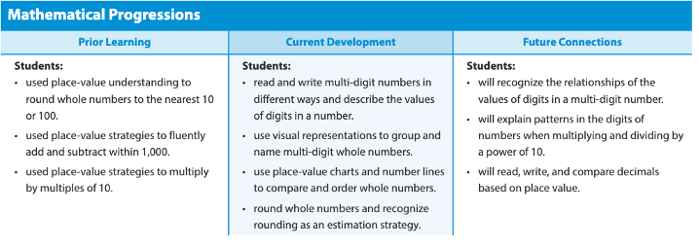
The Coherence Maps from Achieve the Core may also be useful since they relate standards covered in the current grade to similar standards covered in prior grades (or in some cases to standards that may have been covered earlier in the current grade).
      - Future Connections: Enter a bulleted list of skills (first word lowercase, ending with a period) that are related to the module’s Key Topics but that students will learn in later modules or in later grades of IM v2. As with the Prior Learning section, the Mathematical Progressions charts for the source modules in the v1 TE and the Coherence Maps from Achieve the Core are good resources for generating these skills.
    - What will students learn in this module? California Page
      - Copy and paste all content from the section above for the National page into this section.
      - In addition, to the right of the text “Big Idea”, list the codes of the CA Focus standards covered in the module. The codes should be listed in the order they appear in the CA math standards PDF.
    - What is the flow of the module?
      - Enter the number of days for “Lessons” in the form “X Days”. Each lesson is 1 day for Grades K-5 and 2 days for
Grades 6-A1. So, for example, if a module has 6 lessons, you would enter “6 Days” if the module is in K-5 and “12 Days” if the module is in 6-A1.
      - In the text “Module X Project”, replace “X” with the module number.
    - What lessons are in this module?
      - The text after “A lesson is:” should be as follows for
Grades K-5:
        - Approximately 45 minutes of an Essential Session
        - 15+ minutes of suggested Differentiation and Practice Opportunities
      - The text after “A lesson is:” should be as follows for
Grades 6-A1:
        - Approximately 90 minutes of an Essential Session
        - 30+ minutes of suggested Differentiation and Practice Opportunities
      - Planning Support
        - All text is boilerplate.
      - Complete the small gray lesson tables.
        - Number the tables as LESSON 1, LESSON 2, and so on in the first row of the tables. Delete any lesson tables that are not needed.
        - For each lesson, insert the lesson title from Column B of the TOC in the second row of the table.
        - Consult the lesson-level EMM to fill in the sections labeled Learning Objective, Individual Materials, Pairs Materials, Printables, and Digital.
  - Complete the green “Mathematical Language” section.
    - Vocabulary
      - Reference the Vocabulary Guidelines when completing this section. https://hmhco.box.com/s/7n3aijtgf1g55zgqeur0v9epcq33wh8c
      - In the row for Words to Learn, use the Vocabulary Tracker at the following link to determine the new vocabulary words defined in the module. https://hmhco.box.com/s/zfgd7e3zztsmnikn5s91u0aul0hexprm
List the vocabulary words and associated lessons in order by lesson number. If a lesson has multiple vocabulary words, list the words for the lesson in alphabetical order. If the module has no new vocabulary words, enter “N/A” in place of the bulleted list, and change the boilerplate in the first cell of the Words to Learn row to the following: “Use Words to Learn (WTL) in Classcraft or use it together with the module’s WTL Vocabulary Cards to help students master any review terms.” (Change “students” to “children” for K-2.)
      - In the row for high-utility words, use the High-Utility Words Tracker at the following link to determine the high-utility words for the module. https://hmhco.box.com/s/z96pcu29e0p7kgrm1znl70bzdylm99tr
List the high-utility words and associated lessons in order by lesson number. If a lesson has multiple high-utility words, list the words for the lesson in alphabetical order.
    - Mathematical Language Routines (MLRs)
      - List the MLRs used in the Spark Your Learnings and tasks of the lessons in the module. These MLRs can be found in the lesson-level EMMs—specifically, in the “Learn” column of the table in the section titled “What is the flow of the Essential Session?” List each MLR followed by the lesson(s) where it appears, or “all lessons” if it appears in every lesson. List the MLRs in order by lesson number, with MLRs appearing in all lessons listed first and MLRs ordered alphabetically in the case of “ties” (e.g., if two MLRs appear in exactly the same lessons).
  - For the green “Multilingual Learners” section, copy and paste the necessary ML Key Routines from the folder located here:
https://hmhco.box.com/s/h6pe89bxghv4y2p5i5of3bbx6g2ajhgv

Prerequisite Check

Digital authoring within: Learnosity
- Introduction
  - This work involves updating an assessment component called Prerequisite Check. Review and update of this sections should ensure the following:
    - Appropriate coverage of and alignment to the focus standards covered in each module.
    - Updates to address specific V1 concerns outlined in section 2.
  - Purpose of the section:
    - Prerequisite Check assesses the prerequisites skills and understandings required to succeed with the new learning in this module.
  - The work can be done in 5 steps. In each step, you complete a task for all items in the section before moving to the next step which will be completed for all items in the section. These steps are noted in PURPLE below:

- Determine if the content should be reused, revised, or authored new.
1ST STEP – EVALUATION
  - Start by considering the module as a whole (use the IM_CA_G#_TOC.xlsx and the IM_CA_G#_New & Revised Lessons.docx) to note the specific differences from v1:
    - Is the module appearing earlier or later in the full scope and sequence? How does this impact precursor knowledge?
    - How much have the lessons in the module changed? Does the module…
      - Still contain the same lessons from v1?
      - Include lessons with revisions from v1?
      - Now include lessons from multiple v1 modules?
      - Contain any new lessons?
  - Next, re-read the purpose of each lesson in the module.
  - Use the Into Math v1 TE.pdf to view the v1 aligned standards, I can statement, and instructional tasks for the lesson.
  - Read through the EMM.docx of all lessons in the module to take note of any updates to the standards, I Can statement, or instructional tasks.
    - Standards Make sure you understand exactly which part(s) of the standard(s) this lesson primarily focuses on as well as introduces or applies (changes from v1 will be shown in the IM_CA_G#_TOC.xlsx and the IM_CA_G#_New & Revised Lessons.docx as well).
    - I Can Statement Understand this statement in tandem with the standards.
    - Instructional Tasks Read and understand the steps of each task, taking special note of not only what is being asked, but how it is being asked, what models are used, how the student is expected to respond, and the extent to which the student is taught the concepts or skills.
Note: The content of a lesson may stretch students’ thinking a bit beyond the strict expectation of the standard. The assessment items, however, should NOT go beyond the strict expectations of the focus standards.

Rule The Prerequisite Check section will NOT contain any manually scored items. Consider how you can assess the standard with an auto scorable interaction using the Math Item Specs Guide.pdf (see Use Cases and Scoring).

  - Notice how much space on the page the current versions of the items in v1 occupy. These assessment sections will need to take up this exact amount of space, even if revisions are made:
    - Rule Prerequisite Check fits on 1 page
  - Take note of a few assessment-specific criteria listed in the 5TH STEP of these guidelines. Though you can wait until the end to do this sweep, you may want to make note of these look-fors now when considering item revisions and concentration of lesson/standard coverage.
  - Build out the table on your EMM pages to match the number of items in this section currently in the v1 source module.
    - Input the item # shared by print and digital in the first column (multi-part items should use the item # for a paragraph stem and then the item number plus a letter a, b, c, etc. for each part)

- Steps for Reused Content (per item)
  - Due to the comprehensive guidelines around digital and print parity, it is likely that no questions in these sections will be reused as-is without any changes. Please refer to the next item in the outline: Steps for Revised Content.

- Steps for Revised Content (per item)
2ND STEP – PARITY
  - Read the problem as it stands in the Into Math v1 TE.pdf. Evaluate the item on each of the following:
    - For Prerequisite Check, does the item appropriately assess the prerequisite skills?
    - Does the item require multiple distinct interactions within the single problem?
      - Example: student must give an answer AND explain, or student must give an answer AND show their work.
      - In these situations, the item will need to be reauthored as a multi-part item with multiple interactions and considerations in the following steps.
  - Next, review the digital instance of the item in v1 in the Learnosity AYR or MDR Activity against how it appears in the Into Math v1 TE.pdf.
  - Use the Math Item Specs Guide.pdf (see Use Cases) to analyze the question type and understand parity between print and digital (see Digital & Print Parity) while answering each of the following:
    - Which question type would be used in Learnosity to represent the item?
      - Consider using a variety of item types throughout the section.
      - The question type chosen in v1 may still be appropriate in many situations.
      - Add your chosen Learnosity question type to the second column on the EMM.docx.
    - How can the item be written or rewritten (in both mediums) so that the structure and layout of the question matches?
      - This includes the stem, direction line (if applicable), image/art, etc.
      - Rule In all situations, we should strive for parity in question structure and layout.
      - Add your chosen question/stem wording to the "Student Content” column on the EMM.docx.
        - Use Question Stem: in a multi-part item for the paragraph of context used in all parts of the item or in a single-part item for the context of the entire question.
        - Use Direction Line: in a multi-part item for the content/question of a “part.” or a single-part item to designate the specific direction line shared by print and digital. Refer to the Math Item Specs Guide.pdf (see Direction Lines and the question type’s section)
        - With art/photo pieces, include the tech art filename and alt text at point of use. If the art/photo existed in v1, take a screenshot of the art piece, and paste it into the manuscript as scrap.
    - How can the item be written or rewritten (in both mediums) so that the structure and layout of the answer matches?
      - This includes distractors (if applicable), units after a response box, etc.
      - Rule In nearly all situations, we should strive for parity in answer structure and layout. There may be a rare case where the answer structure or layout cannot reach full parity based on limitations of either print or digital (e.g. a picture graph with appropriate labels).
      - Add your chosen answer line/structure to the "Student Content” column on the EMM.docx.
        - Use pink text for the answers of each question. This pink text should be in the exact format to be repurposed as the annos in print or specific answers in digital. Anywhere where there would be a response box in digital (and a WOL in print), use brackets [] to show a response box with the expected answer.
Example: [5] miles
        - If blank space is desired on the print page (or any other comment to the Compositor which will not actually be visible on the Student Edition page), this can be shown with a note in brackets [] and gray text. Example: [Possible answer: 2 + 2 = 4] (this would mean no WOL is needed since it is in gray)
    - How can the item be written or rewritten (in both mediums) so that the student’s interaction matches?
      - Rule In nearly all situations, we should strive for parity in student interaction. There may be a rare case where the interaction cannot reach full parity based on limitations of either print or digital (e.g. a box and whisker plot).
      - Adjust your chosen Learnosity question type in the second column on the EMM.docx.
      - With Print Content: In the same left-hand column that the block type/pattern is listed, we also need to accommodate for how the content will appear in print.
      - Parity with print is important to keep in mind, with the idea that students should produce the same answer in both formats.
        - In cases where a student may use a Drop Down pattern in Learnosity (Grades 3-A1), the print content will appear on a write on line (WOL). For Drag and Drop patterns, a word bank is not always necessary to include in print depending on the amount of space on a page. Both these situations will break parity and that has been agreed upon as acceptable.

3RD STEP – SETTINGS
  - Use the Learnosity Question Type Use Cases Table Structure.docx as a jumping off point for understanding question type use cases and which fields need to be included in the "Student Content" column of the EMM. This document in conjunction with the Math Item Specs Guide.pdf (see the question type’s section) will help you write up any Learnosity item to exact specifications.
    - Use Changes to Spec Guide Settings: to list specific settings for the digital item noting specifically the fields which deviate from the settings outlined in the spec guide (make sure to read through the first and second pages of that question type, especially noting the starred fields).
    - Include Feedback (called Rationale per Response or Rationale per Question) and Hints for the question if the item sits in a MDR section, but not for AYR (see Feedback & Hints).

4TH STEP – ALIGNMENTS
  - Finally in column 3, list information about the standard alignments and DOK for each question:
    - Use Alignments: to list the standard codes of the standards being assessed by the item.
      - In most situations, this should be a single Common Core State Standard (CCSS) and a single California (CA) standard. Use the Learning Spine to CCSS Mapping.xlsx to identify at least one learning spine skill (search the spreadsheet by the chosen CCSS and choose one or multiple learning spine skills which are aligned to that CC standard).
      - List the Depth of Knowledge level for the question as well using Depth of Knowledge.pdf
      - Rule 1 Every item (or every part in a multi-part item) should have at least one tag to CCSS, at least one tag to CA, at least one tag to the Learning Spine and one DOK.
      - Rule 2 If an item can truly be aligned to more than one CCSS or CA standard or Learning Spine Skills, multiple can be included in the EMM – just indicate which standard/skill is the primary CCSS, primary CA, or primary Learning spine skill by putting (primary) after it. The rest will be secondary tags.
      - Rule 3 Prerequisite Check assesses pre-requisite skills which are sometimes sourced from a previous grade. If this is the case, your alignment tags can come from a previous grade. Consider using the v1 source lessons in the Data-Driven Intervention table to give you a reference for which standards you could use.
    - One other alignment to be considered is a tag to a Standard for Mathematical Practice (SMP). Please refer to SMP Guidelines.docx for more information. Things to check:
      - Rule Prerequisite Check will not use SMPs.
    - For the Prerequisite Check section, there is one more table beneath the three-column table for inputting items which is titled Data-Driven Support. This table should be populated with the appropriate information (and can be revised from what is in the Into Math v1 TE.pdf):
      - Input the Item # shared by print and digital in the first column (multi-part items should use the item # for a paragraph stem and then the item number plus a letter a, b, c, etc. for each part). Consecutive items can be grouped together in the same row if the information is the same for the other columns to save space.
      - Input the Content Focus for each item/part. Take note of if prerequisite skills in this section have changed. Notice that on the SE page, these Content Focus titles are the headings for each group of items on the actual page. Match the style and format from v1:
        - Headers in column 2 are a capitalized, short phrase or word to name the pre-requisite skill.
        - The longer description in column 3 is a sentence beginning with an action verb that describes the specific skill.
      - Input the Intervention (RTI tier 2 skill worksheet) which addresses each prerequisite skill in the column 4.

5TH STEP – ASSESSMENT SPECIFICS
  - Complete one final sweep of this section’s content for these common issues that were prevalent in our v1 assessments that we’d like to avoid in v2 (use the Print and Digital Errors from v1 Assessments.docx to view examples and more details):
    - Is the item ambiguous enough to allow for multiple interpretations? If so, it will need to be revised.
    - Does the item have “Possible Answers” as the anno but does not truly have more than one correct, non-equivalent answer? Then the annos must be revised.
      - Rule Possible answers should only be used for questions which allow for more than one, non-equivalent answer.
      - Example: A rectangle has an area of 12 sq units. What are possible side lengths of the rectangle? Since multiple, non-equivalent answers are possible this should be marked possible answer.
      - Non-Example: What is ½ + 2/8? While there are multiple representations of the correct answer (6/8, 3/4), since they are equivalent, they should not be marked “Possible Answers”.
    - Does the item involve a unit, either standard or non-standard. If so, the units used in answer lines (unless explicitly stated in the standard language) should be provided for the student in print and digital (i.e. <response box> units). Examples of units include inches, pages per day, and baskets of apples.
    - Does the item contain directional references – (e.g. “Use the table below” or “Use the picture on the right.”) If so, it must be revised to remove this reference (e.g. “Use the table” or “Use the picture”).
  - Next, consider a few assessment-specific requirements:
    - For Prerequisite Check, check the following:
      - The pre-requisite concepts assessed here are still taught in prior lessons based on the new sequencing of lessons.
      - The lessons each pre-requisite concept is related to are still in this module.
        - Rule Each AYR section will have content organized under at least 3 headings. The content below each heading represents prerequisite knowledge which supports the learning objectives of the current module. The prerequisite knowledge can either come from earlier grades, or earlier modules within the grade.
        - Rule Each AYR can contain only auto-scored questions.
    - Finally, consider all the revisions you made to items in the section. Ensure that the spacing of these items will still fit in the allotted number of pages.

- Steps for New Content (per item)
  - See “Steps for Reused Content”. The process for writing new items is the same as revising items except for not having an item in v1 to reference.
  - Ensure that any new items authored also match the lesson’s objectives and the models, language, and format of the instructional tasks.

Resources:
- IM_CA_G#_TOC.xlsx (Box Folder)
- IM_CA_G#_New & Revised Lessons.docx (Box Folder)
- Into Math v1 TE.pdf (Ed Platform) (Box Folder)
- Learnosity AYR or MDR Activity (Ed Platform)
- Into Math v1 Assessment Guide (Ed Platform)
- EMM.docx (Box Folder)
- Math Item Specs Guide.pdf (Box Folder)
- Manually Scored Items by Standard & Lesson.xlsx (Box Folder)
- Depth of Knowledge.pdf (Box Folder)
- Learning Spine to CCSS Mapping.xlsx (Box Folder)
- Print and Digital Errors from v1 Assessments.docx (Box Folder)
- SMP Guidelines.docx (Box Link)

Module Closer Guidelines

Module Review

Digital authoring within: Learnosity

- Introduction
  - This work involves updating a practice component called Module Review (MDR). Review of this section should ensure the following:
    - Appropriate coverage of and alignment to the focus standards covered in each module.
    - Updates to address specific V1 concerns outlined in section 2.
  - Purpose of component:
    - Module Review serves as a final practice and review of the module content.
    - The Vocabulary section reviews the new terms introduced in the module.
      - For Grade K, see the Module Review section under Kindergarten Considerations.
      - For Grades 1–A1, enter new vocabulary words in the Vocabulary Box within the EMM.docx, using the following guidance:
        - If print requires a Word Bank for students to complete the Vocabulary section, list all new vocabulary words from the module in the Word Bank, and be sure there is parity with the digital pattern.
        - If the item type is line matching in print, the digital pattern is “Match List”, and a Word Bank is not included for either component. N/A is entered in the Vocabulary Box section of the EMM.
        - Due to spacing, all new terms will not be represented as an item in the Vocabulary section. For G1–A1, only 2–5 vocabulary items can be authored. Those 2–5 terms should reflect the most critical content for the module.
        - If the module has only one new term, then choose at least one review term as a distractor for the Word Bank.
        - If there are no new vocab terms for the module, then type "N/A" in the Vocabulary Box as well as in the Item # and Learnosity Item Type columns under the Vocabulary section.
    - The Concepts and Skills section provides practice of the module content.
      - This section is part of every Module Review.
  - The Module Review should mirror the lesson’s objectives as well as the models, language, and format of the instructional tasks as well as staying parallel to the v1 Module Test.
  - The work for the section can be done in 5 steps. In each step, you complete a task for all items in the section before moving to the next step which will be completed for all items in the section. These steps are noted in PURPLE below:

- Determine if the content should be reused, revised, or authored new.
1ST STEP – EVALUATION
  - Start by considering the module as a whole (use the IM_CA_G#_TOC.xlsx and the IM_CA_G#_New & Revised Lessons.docx) to note the specific differences from v1:
    - Is the module appearing earlier or later in the full scope and sequence? How does this impact precursor knowledge?
    - How much have the lessons in the module changed? Does the module…
      - Still contain the same lessons from v1?
      - Include lessons with revisions from v1?
      - Now include lessons from multiple v1 modules?
      - Contain any new lessons?
  - Next, re-read the purpose of each lesson in the module.
  - Use the Into Math v1 TE.pdf to view the v1 aligned standards, I can statement, and instructional tasks for the lesson.
  - Read through the EMM.docx of all lessons in the module to take note of any updates to the standards, I Can statement, or instructional tasks.
    - Standards Make sure you understand exactly which part(s) of the standard(s) this lesson primarily focuses on as well as introduces or applies (changes from v1 will be shown in the IM_CA_G#_TOC.xlsx and the IM_CA_G#_New & Revised Lessons.docx as well).
    - I Can Statement Understand this statement in tandem with the standards.
    - Instructional Tasks Read and understand the steps of each task, taking special note of not only what is being asked, but how it is being asked, what models are used, how the student is expected to respond, and the extent to which the student is taught the concepts or skills.
Note: The content of a lesson may stretch students’ thinking a bit beyond the strict expectation of the standard. The assessment items, however, should NOT go beyond the strict expectations of the focus standards.
  - Use the Manually Scored Items by Standard & Lesson.xlsx to decide if this lesson’s truncated standards (listed on the Before You Teach section of the EMM.docx) require a drawing/modeling interaction, an explain/justify interaction, or a choice of how to represent their thinking interaction (these are manually scored questions).
    - Rule The Module Review section for a lesson can contain up to 2 manually scored questions. Use the Manually Scored Items by Standard & Lesson.xlsx (and refer to practice items in the lessons of the module) to decide if this lesson’s standards require a manually scored question in tandem with the Math Item Specs Guide.pdf (see Use Cases and Scoring).
  - Notice how much space on the page the current versions of the items in v1 occupy. These assessment sections will need to take up this exact amount of space, even if revisions are made:
    - Rule Module Review fits on 2 pages
  - Take note of a few assessment-specific criteria listed in the 5TH STEP of these guidelines. Though you can wait until the end to do this sweep, you may want to make note of these look-fors now when considering item revisions and concentration of lesson/standard coverage.
  - Build out the table on your EMM pages to match the number of items in this section currently in the v1 source module.
    - Input the item # shared by print and digital in the first column (multi-part items should use the item # for a paragraph stem and then the item number plus a letter a, b, c, etc. for each part)

- Steps for Reused Content (per item)
  - Due to the comprehensive guidelines around digital and print parity, it is likely that no questions in these sections will be reused as-is without any changes. Please refer to the next item in the outline: Steps for Revised Content.

- Steps for Revised Content (per item)
2ND STEP – PARITY
  - Read the problem as it stands in the Into Math v1 TE.pdf. Evaluate the item on each of the following:
    - For the Module Review,
      - does the item reasonably match the format/structure in which students learned the skill or knowledge in a lesson? (refer to practice items in the lessons)
      - does the item appropriately assess the standard?
      - does the item’s format/structure match what is on the Module Test?
      - Note: though we aren’t developing the Module Tests now, we should default to matching the Module Test format/structure with one exception: If the Module Test items do not match the format/structure of practice items from the lessons in the module and will need to be changed as well, align your Module Review format/structure to the practice items from the lessons and the Module Test developers will know to look for this.
    - Does the item require multiple distinct interactions within the single problem?
      - Example: student must give an answer AND explain, or student must give an answer AND show their work.
      - In these situations, the item will need to be reauthored as a multi-part item with multiple interactions and considerations in the following steps.
  - Next, review the digital instance of the item in v1 in the Learnosity AYR or MDR Activity against how it appears in the Into Math v1 TE.pdf.
  - Use the Math Item Specs Guide.pdf (see Use Cases) to analyze the question type and understand parity between print and digital (see Digital & Print Parity) while answering each of the following:
    - Which question type would be used in Learnosity to represent the item?
      - Consider using a variety of item types throughout the section.
      - The question type chosen in v1 may still be appropriate in many situations.
      - Add your chosen Learnosity question type to the second column on the EMM.docx.
    - How can the item be written or rewritten (in both mediums) so that the structure and layout of the question matches?
      - This includes the stem, direction line (if applicable), image/art, etc.
      - Rule In all situations, we should strive for parity in question structure and layout.
      - Add your chosen question/stem wording to the "Student Content” column on the EMM.docx.
        - Use Question Stem: in a multi-part item for the paragraph of context used in all parts of the item or in a single-part item for the context of the entire question.
        - Use Direction Line: in a multi-part item for the content/question of a “part.” or a single-part item to designate the specific direction line shared by print and digital. Refer to the Math Item Specs Guide.pdf (see Direction Lines and the question type’s section)
        - With art/photo pieces, include the tech art filename and alt text at point of use. If the art/photo existed in v1, take a screenshot of the art piece, and paste it into the manuscript as scrap.
    - How can the item be written or rewritten (in both mediums) so that the structure and layout of the answer matches?
      - This includes distractors (if applicable), units after a response box, etc.
      - Rule In nearly all situations, we should strive for parity in answer structure and layout. There may be a rare case where the answer structure or layout cannot reach full parity based on limitations of either print or digital (e.g. a picture graph with appropriate labels).
      - Add your chosen answer line/structure to the "Student Content” column on the EMM.docx.
        - Use pink text for the answers of each question. This pink text should be in the exact format to be repurposed as the annos in print or specific answers in digital. Anywhere where there would be a response box in digital (and a WOL in print), use brackets [] to show a response box with the expected answer.
Example: [5] miles
        - If blank space is desired on the print page (or any other comment to the Compositor which will not actually be visible on the Student Edition page), this can be shown with a note in brackets [] and gray text. Example: [Possible answer: 2 + 2 = 4] (this would mean no WOL is needed since it is in gray)
    - How can the item be written or rewritten (in both mediums) so that the student’s interaction matches?
      - Rule In nearly all situations, we should strive for parity in student interaction. There may be a rare case where the interaction cannot reach full parity based on limitations of either print or digital (e.g. a box and whisker plot).
      - Adjust your chosen Learnosity question type in the second column on the EMM.docx.
      - With Print Content: In the same left-hand column that the block type/pattern is listed, we also need to accommodate for how the content will appear in print.
      - Parity with print is important to keep in mind, with the idea that students should produce the same answer in both formats.
        - In cases where a student may use a Drop Down pattern in Learnosity (Grades 3-A1), the print content will appear on a write on line (WOL). For Drag and Drop patterns, a word bank is not always necessary to include in print depending on the amount of space on a page. Both these situations will break parity and that has been agreed upon as acceptable.

3RD STEP – SETTINGS
  - Use the Learnosity Question Type Use Cases Table Structure.docx as a jumping off point for understanding question type use cases and which fields need to be included in the "Student Content" column of the EMM. This document in conjunction with the Math Item Specs Guide.pdf (see the question type’s section) will help you write up any Learnosity item to exact specifications.
    - Use Changes to Spec Guide Settings: to list specific settings for the digital item noting specifically the fields which deviate from the settings outlined in the spec guide (make sure to read through the first and second pages of that question type, especially noting the starred fields).
    - Include Feedback (called Rationale per Response or Rationale per Question) and Hints for the question if the item sits in a MDR section, but not for AYR (see Feedback & Hints).
      - Rule The questions in the Vocabulary section of the MDR will NOT have authored feedback or hints. But the Concepts and Skills section WILL have authored feedback and hints.
    - Use Rubric: on a manually scored question to give the rubric which should be used to help teacher’s manually score the single-part item or specific part of a multi-part item. Insert a 2x4 table in the EMM which contains the boilerplate rubric text as well as a “Possible Answer” in each point value designation. Refer to the Math Item Specs Guide.pdf (see Rubrics and the question type’s section).

4TH STEP – ALIGNMENTS
  - Finally in column 3, list information about the standard alignments and DOK for each question:
    - Use Alignments: to list the standard codes of the standards being assessed by the item.
      - In most situations, this should be a single Common Core State Standard (CCSS) and a single California (CA) standard. Use the Learning Spine to CCSS Mapping.xlsx to identify at least one learning spine skill (search the spreadsheet by the chosen CCSS and choose one or multiple learning spine skills which are aligned to that CC standard).
      - List the Depth of Knowledge level for the question as well using Depth of Knowledge.pdf
      - Rule 1 Every item (or every part in a multi-part item) should have at least one tag to CCSS, at least one tag to CA, at least one tag to the Learning Spine and one DOK.
      - Rule 2 If an item can truly be aligned to more than one CCSS or CA standard or Learning Spine Skills, multiple can be included in the EMM – just indicate which standard/skill is the primary CCSS, primary CA, or primary Learning spine skill by putting (primary) after it. The rest will be secondary tags.
    - One other alignment to be considered is a tag to a Standard for Mathematical Practice (SMP). Please refer to SMP Guidelines.docx for more information. Things to check:
      - Rule Prerequisite Check will not use SMPs.
      - Rule Every Module Review should have only 1 exercise that assesses an SMP. Only SMPs that were covered in the module’s lessons are eligible for assessment in the Module Review.
      - To add an SMP tag to an item in the EMM, give the icon and SMP name in bold at the beginning of the item’s stem:
        - Example: [MP/SMP icon] MP Name Question...
      - Update the SMP tracker with the information as well. More info to come.
    - For the Prerequisite Check section, there is one more table beneath the three-column table for inputting items which is titled Data-Driven Support. This table should be populated with the appropriate information (and can be revised from what is in the Into Math v1 TE.pdf):
      - Input the Item # shared by print and digital in the first column (multi-part items should use the item # for a paragraph stem and then the item number plus a letter a, b, c, etc. for each part). Consecutive items can be grouped together in the same row if the information is the same for the other columns to save space.
      - Input the Content Focus for each item/part. Take note of if prerequisite skills in this section have changed. Notice that on the SE page, these Content Focus titles are the headings for each group of items on the actual page. Match the style and format from v1:
        - Headers in column 2 are a capitalized, short phrase or word to name the pre-requisite skill.
        - The longer description in column 3 is a sentence beginning with an action verb that describes the specific skill.
      - Input the Intervention (RTI tier 2 skill worksheet) which addresses each prerequisite skill in the column 4.

    - For the Module Review section, there is one more table beneath the three-column table for inputting items which is titled Data-Driven Support. This table should be populated with the appropriate information (and can be revised from what is in the Into Math v1 TE.pdf):
      - Input the Item # shared by print and digital in the first column (multi-part items should use the item # for a paragraph stem and then the item number plus a letter a, b, c, etc. for each part). Consecutive items should be grouped together in the same row if the information is the same for the other columns to save space.
      - Input the Content Focus for each item/part. The content focus in column 2 is a sentence beginning with an action verb that describes the specific skill.
      - Input the Intervention (reteach for a specific lesson in this v2 module) which addresses each skill.
      - Check the concentration of lessons referenced in this module review – are there any not referenced? Are there any lessons which are too heavily referenced based on the standards of this module?

5TH STEP – ASSESSMENT SPECIFICS
  - Complete one final sweep of this section’s content for these common issues that were prevalent in our v1 assessments that we’d like to avoid in v2 (use the Print and Digital Errors from v1 Assessments.docx to view examples and more details):
    - Is the item ambiguous enough to allow for multiple interpretations? If so, it will need to be revised.
    - Does the item have “Possible Answers” as the anno but does not truly have more than one correct, non-equivalent answer? Then the annos must be revised.
      - Rule Possible answers should only be used for questions which allow for more than one, non-equivalent answer.
      - Example: A rectangle has an area of 12 sq units. What are possible side lengths of the rectangle? Since multiple, non-equivalent answers are possible this should be marked possible answer.
      - Non-Example: What is ½ + 2/8? While there are multiple representations of the correct answer (6/8, 3/4), since they are equivalent, they should not be marked “Possible Answers”.
    - Does the item involve a unit, either standard or non-standard. If so, the units used in answer lines (unless explicitly stated in the standard language) should be provided for the student in print and digital (i.e. <response box> units). Examples of units include inches, pages per day, and baskets of apples.
    - Does the item contain directional references – (e.g. “Use the table below” or “Use the picture on the right.”) If so, it must be revised to remove this reference (e.g. “Use the table” or “Use the picture”).
  - Next, consider a few practice-specific requirements:
    - For Module Review, check the following:
      - Ensure that these have a similar and appropriate balance/concentration of focus standards and are well-aligned to both the revised module and to each other.
      - Rule There should be a clear connection between the Module Review and Module Test. The Module Review is designed to give students an opportunity to practice the skills of the module and prepare for the Module Test.
        - For example, if 20% of the items in the Module Review assess a given standard, a similar percentage of items in the Module Test should assess that standard.
    - Finally, consider all the revisions you made to items in the section. Ensure that the spacing of these items will still fit in the allotted number of pages.

- Steps for New Content (per item)
  - See “Steps for Reused Content”. The process for writing new items is the same as revising items except for not having an item in v1 to reference.
  - Ensure that any new items authored also match the lesson’s objectives and the models, language, and format of the instructional tasks.

Resources:
- IM_CA_G#_TOC.xlsx (Box Folder)
- IM_CA_G#_New & Revised Lessons.docx (Box Folder)
- Into Math v1 TE.pdf (Ed Platform) (Box Folder)
- Learnosity AYR or MDR Activity (Ed Platform)
- Into Math v1 Assessment Guide (Ed Platform)
- EMM.docx (Box Folder)
- Math Item Specs Guide.pdf (Box Folder)
- Manually Scored Items by Standard & Lesson.xlsx (Box Folder)
- Depth of Knowledge.pdf (Box Folder)
- Learning Spine to CCSS Mapping.xlsx (Box Folder)
- Print and Digital Errors from v1 Assessments.docx (Box Folder)
- SMP Guidelines.docx (Box Link)

Kindergarten Considerations
Kindergarten will follow the guidelines above for the majority of the sections, however there are additional GK considerations that need to be made when authoring the EMM. Information about those considerations will be found within this section.

Kindergarten Page Styling Guidelines
Kindergarten is the only grade that is image based, so the content needs a specific page style to organize the images. There needs to be a total of 6 pages in each GK lesson, unless otherwise indicated in the TOC. Page styles can be mixed and matched to reach this page requirement.
- Images can be organized within one task, or may be organized across multiple tasks.
  - If multiple source lesson tasks share a direction line, those tasks will be considered one task in v2. Choose a page layout (Styles A-F) for a single task and include it in the EMM in the Print Page Style row.
  - If multiple source lesson tasks share a direction line but include separate stories, those tasks will be considered separate tasks. (Please author the direction line in both tasks, but the direction line should be gray in the second task since it will not appear in print twice. The stories should be black in both tasks.) Choose a page layout (Styles G-M) for a multiple tasks and include it in the EMM in the Print Page Style row.
    - If for any reason a page style needs to be modified, such as needed two small boxes side by side where the page style only shows one long box, a note to COMP can be included in the same row in the EMM that the page style is indicated. In brackets, please tell COMP the modification you need for that page style.
    - For example, if instead of two large boxes stacked on top of each other such as in Style B you needed one large box and two smaller boxes below side by side, you can instruct comp to make that change.
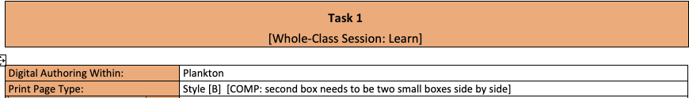
- May choose a layout that resembles what was done for v1 for p/u lessons
- Revised/new lessons will require a page style that makes sense for the content
- Page types for new/revised lessons should be chosen at the end of authoring the EMM to ensure all the content is represented correctly
- The task number on the EMM will correlate with the color and icon. Any page style can be used for any task.
  - For example, if Task 1 needs Page Style A (one large single box) and Task 2 also needs Page Style A, comp will know to change the icon and colors.
- Please fill out the Page Layout of the Lesson table in the Before You Teach section to ensure that the page layout works with the number of pages as well as the master templates that cannot change.
  - The order of pages may be rearranged to account for the layout of the lesson. For example, if there are two full pages of tasks, then page 2 and 3 would both be tasks x–x, page 4 would be Rev SYL, page 5 would be QC master, and there would be only 1 page for PoYO. In any case where there are 8 pages listed on the TOC instead of 6, additional columns may be added to account for those pages. Add any modifications that are needed within the brackets after the page style letter (included on template).
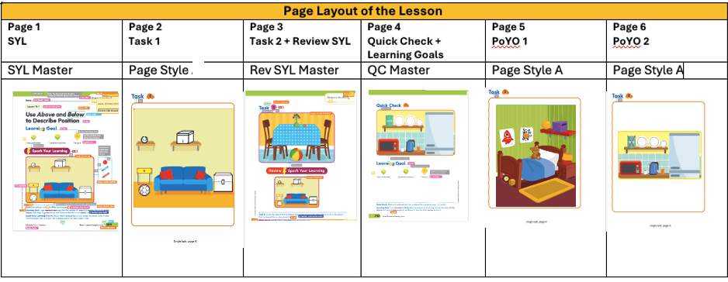

Master Templates vs. Page Styles
- Some sections will have master templates – parts of these templates do not change:
  - SYL – The SYL must be one image that fits inside of the templated box. Size of box and location of box do not change.
  - SYL Review – This image is the same as the SYL above. Size of box and location of box do not change.
  - Quick Check – This is templated on the page meaning the location cannot change. However, if two smaller images side-by-side are needed, that modification may be made. Can include a note to comp similar to above.
  - Assess Learning Goal – Boilerplate. Does not change
- Other sections of the template have Page Styles. These page styles may be chosen from the templates linked and modified as needed:
  - Tasks and Practice on Your Own are the only sections that need page styles indicated for Lesson Level EMMs and the same rules apply to each. The main difference is that the word Task will appear before the icon on the page, and the words Practice on Your Own will appear before the icon on the page. This is already indicated within the section of the EMM, so no need to do anything additional here besides choosing the page style.
  - Prerequisite Check (formerly known as Are You Ready) and Module Review will also require page styles indicated for Module Level EMMs

Reused Content from the Source Lesson
- May choose a layout that resembles what was done for v1 for p/u lessons
- If a V1 lesson has 3 tasks, Task 1 needs to take up the whole page (Styles A–F) and Task 2 needs to sit above the Review SYL, Task 3 becomes Quick Check above Learning Goals.
- If a V1 lesson has 4 tasks, Task 1 and Task 2 needs to be represented using a page style from G–J, Task 3 needs to sit above the Review SYL, Task 4 becomes Quick Check above Learning Goals.
- If a V1 lesson has more than 4 tasks, any mix of page styles can be used as long as the second to last task sits above the SYL Review and the last task becomes the Quick Check.
- For visuals, please see the GK Page Styling Slide Deck.

Revised or New Content
- If a lesson is new or revised, any mix of page styles can be used if the master templates are still considered.
- Best practice to author the EMM last, and then consider the page type that will correctly reflect the sequence of the tasks. Remember that the SYL Review section does not move, so there needs to be a task on the page above it. Additionally remember the Assess Learning Goal section does not move, so there must be a Quick Check above it.
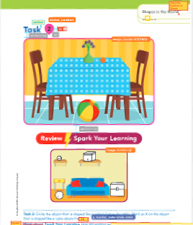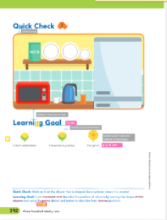

Additional Considerations
Not every v1 page style will work for v2 since we have two templated pages that require content in specific places (Review SYL page and Quick Check). We have pulled out some known issues and solutions for when source lesson page styles do not work. All issues are also represented visually in the GK Page Styling Slide Deck.
  - ISSUE 1: There are 2 tasks and the second task becomes the quick check. No task to put above Review SYL.
  - SOLUTION 1: Pull in a problem from the On Your Own section in V1 if there are more than 2 POYO problems.
  - ISSUE 2: There are 2 tasks and 2 POYO. No problem to put above the quick check.
  - SOLUTION 2: Since all tasks from v1 are accounted for, a new task would need to be written to be placed as Task 2.
      - Before determining if a lesson requires new content to fit the page structures and the 6-page rule, please ensure none of the following is possible:
      - Manipulating the page type to possibly having 1 task per page (multiple A style pages in a lesson)
      - Not combining two tasks that share a direction line (typically the rule is if multiple tasks share a direction line it becomes one task, but if it affects the page styling we would consider this an exception to the rule before advocating for new content)
      - Picking up a PoYO item and placing it as a task (if there are multiple PoYOs to choose from- should have 2 minimum per lesson)
      - If all suggestions have been considered but are not effective, please email HMH the lesson that would need new content for approval before writing new content.
  - ISSUE 3: If there are enough tasks but the page styles that are most similar from v1 result in only 5 pages, not 6.
  - SOLUTION 3: Choose page types that allow the tasks to be spread out to reach 6 pages.
  - ISSUE 4: There are 2 tasks and the second task becomes the quick check. No task to put above Review SYL.
  - SOLUTION 4: Pull in a problem from the On Your Own section in V1 if there are more than 2 POYO problems (if not, see Solution 2).

Module Opener and Module Review
- GK Module Opener and GK Module Closer EMMs have now been separated from the original GK–G2 version to reflect the addition of page styles.
- GK Module Opener and Module Review page styles can be found using the links.
  - The Prerequisite Check (formerly Are You Ready) consists of a mix of different numbers of tasks and headers. While we tried to predict the most common ones that will be used, it is possible that modifications may need to be made. In that case, provide the closest page style and include a comment in brackets to comp describing the change you need (such as an additional task or header and the placement of it)
  - The Module Closer consists of a Vocabulary section and a Concepts and Skills section.
    - The Vocabulary section may include one problem, although multiple new vocabulary terms may be represented within that same problem. This requires a page style that includes the Vocabulary header at the top (Page Style E).
      - If there are no new vocab terms listed, choose a page style that begins with Concepts and Skills
      - The vocabulary word should be represented as an image. Students are using their understanding of the word to answer a question. LXD will provide LXDv with the list of vocabulary terms to use per module.
      - LXD has also marked up v1 PDFs with required vocabulary by v1 module to use as a base.
      - New/modified images will need to be requested for these problems using the regular new image request process
      - Problems in the Vocabulary section should be included in the Data Driven Instruction table at the end for GK.
        - The Vocab problem will be considered #1 (orange car icon). Concepts and Skills will continue to be #2, #3, and so on.
      - Vocabulary problems in GK are more concept based since they aren’t matching a word with a definition the way they are in other grades, so we still want the skill represented in the table even if it is in the vocabulary section.
        - This will also ensure that by moving problems around or relabeling some problems as “vocabulary” we are still hitting the content focus of each lesson within the Module Review.
    - There are many variations of the Concepts and Skills section so this section will require a modification request in brackets. Use the page styles provided, but include specific instructions to comp to modify the style in a way that fits your needs.
  - Please fill out the Page Layout of the Module Opener/Closer on the Module-Level EMM to ensure that page layout chosen is visually represented for LXD/COMP.
    - Please include screen shots of the page style used for the Module Opener- Prerequisite Check. The Prerequisite Check is 1 page for kindergarten. Add any modifications that are needed within the brackets after the page style letter (included on template).
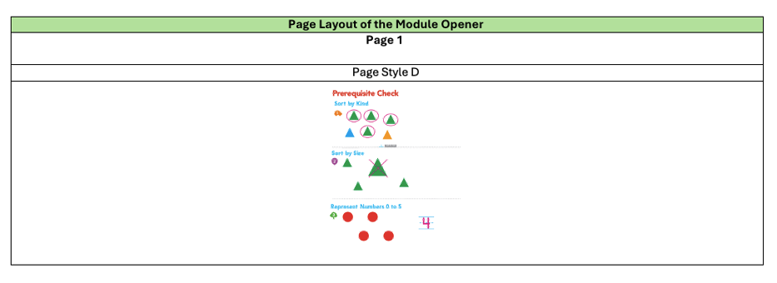
    - Please include screen shots of the page style used for the Module Closer- Vocabulary (if applicable) and Concepts and Skills. This section is 2 pages in kindergarten. Add any modifications that are needed within the brackets.

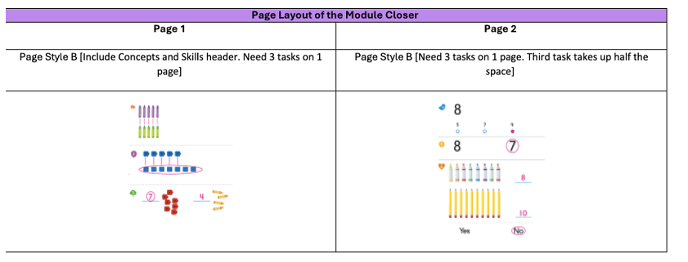

Multiple Versions of Images
Base images are used throughout the Student Edition for tasks in GK. These are images that students will use to write on in their print book or manipulate digitally through interactions. These images follow the Image Guidelines for reused images and for modified/new images.
However, we also need to account for images used within the TE which indicates to the teacher what the correct answer is:

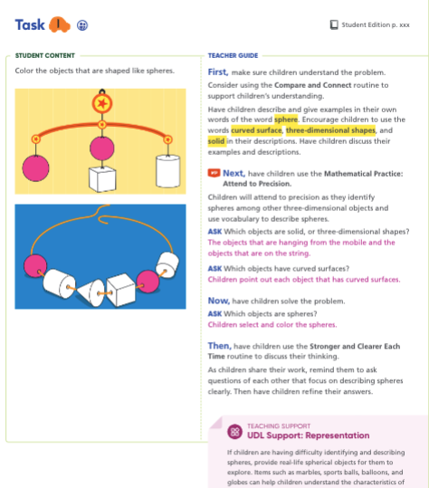

The images on the Student Content side of the TE require an anno (magenta) coloring to indicate to the teacher what the correct answer is. Because all tasks require an image, multiple versions of the same image will need to be listed in the EMM.
Image 1: Base image (used for SE and Digital content) 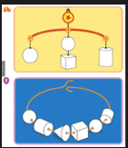
Image 2: Anno version (used for TE) 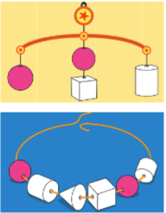

To put this information in the EMM, include the base image information as the “Background Image” in the interaction. Include the anno version as the Print Anno Image and indicate in the alt text which parts are indicated as correct. Please always provide a scrap.
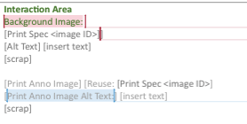

In cases where there is not an indicated correct answer but rather a statement to “Check children’s work”, please include the statement in the EMM as the anno. You do not need to include any other additional information (such as including a representation of the correct answer) if it does not appear in v1.

  - For revised/new lessons, it is up to your discretion whether or not the correct answer is modeled in anno or if it is solely “Check children’s work.” This mainly depends on if there are multiple correct answers.

In other cases, both a model and “Check children’s work” is available on the page.:

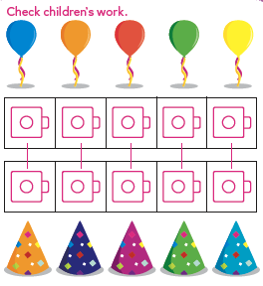
It is our recommendation that if there are multiple answers/representations, then both an example and “Check children’s work” is acceptable. If there is only one correct answer and the answer is represented as the anno, “Check children’s work” is redundant and is not needed.
  - The most recent information relayed to us is that COMP will be responsible for the various versions of the base image, so an image request for the different versions is not necessary. Follow the regular protocol for image requests for the base image only.
- Note that the Spark Your Learning discussions table will require two additional versions of the base image. They are needed for the Addressing Common Errors section and the Deepening Student Thinking section. In all, there are 4 versions of the SYL image needed (base, teacher edition, common errors, deepening student thinking). These images will all come from v1 so the pick up information process will be the same, we just need to account for all images within the EMM and provide the accompanying alt text for each image.

